Maroun Najem – 202210166
GitHub: https://github.com/maroun-202210166/midterm.git

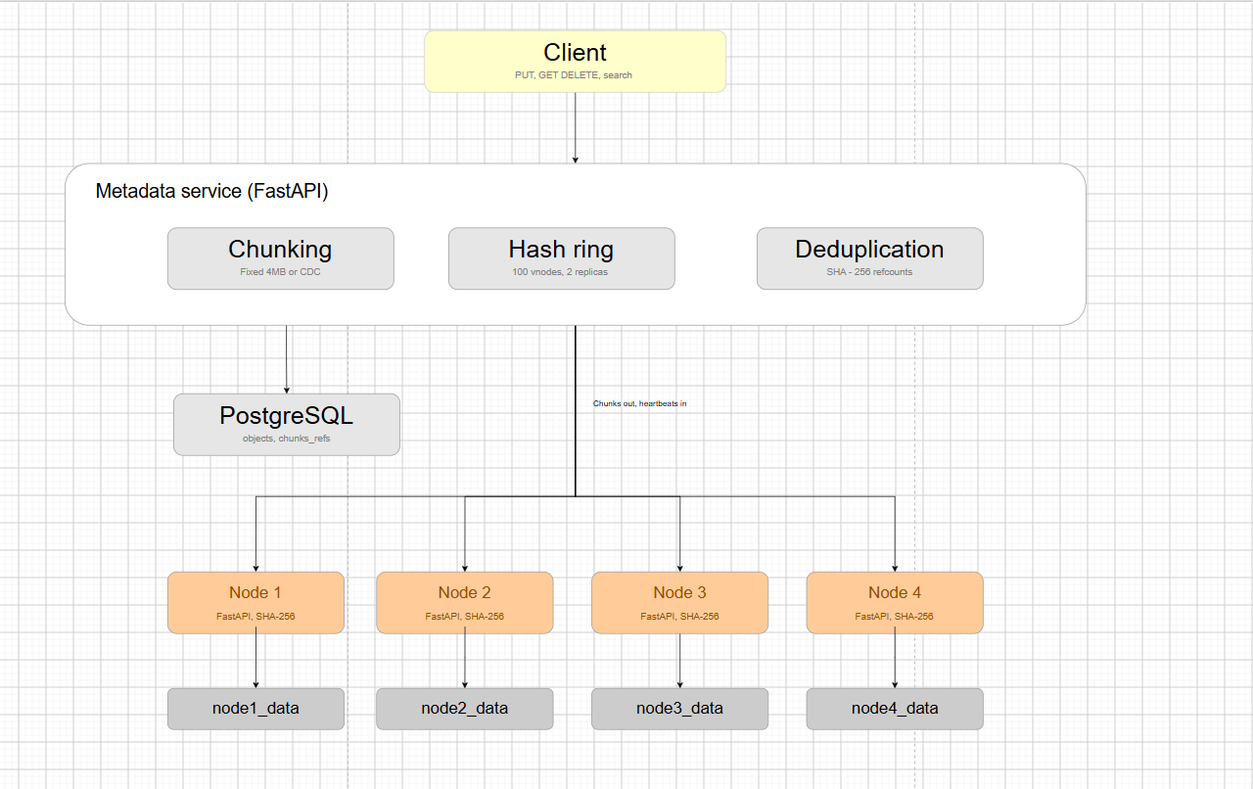
Introduction
This project implements a distributed object-storage system using Python, FastAPI, Docker, PostgreSQL and multiple independent storage nodes. The work is organized into tasks that build the system step by step: environment setup, storage-node services, metadata and chunk placement, redundancy and recovery, an API for data access, a web interface, and bonus features for load balancing, fault tolerance and monitoring. This report documents the design, implementation, tests, measured results, challenges and current limitations.
Task 1: Environment Setup
1- Python and virtual environment
- Python 3.10.11 installed
- venv created with python -m venv venv
- activated with venv\Scripts\activate.

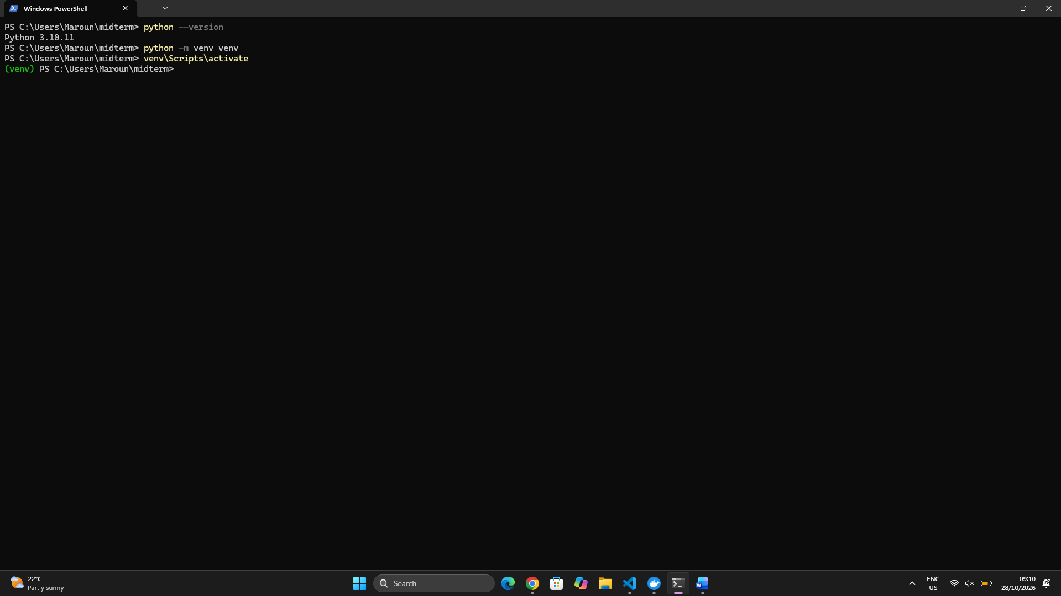

2- Version control:
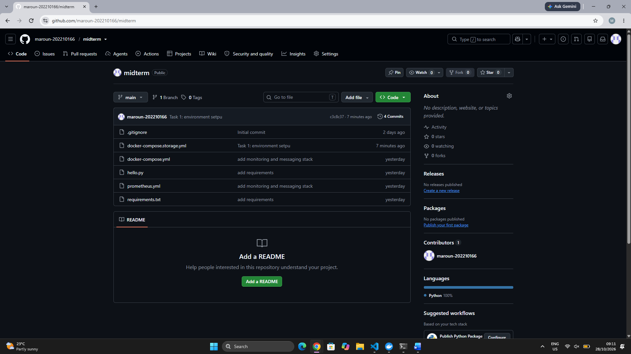

3- Docker and Kubernetes
Docker Desktop installed, Kubernetes enabled with the kubeadm method, and verified with kubectl get nodes.

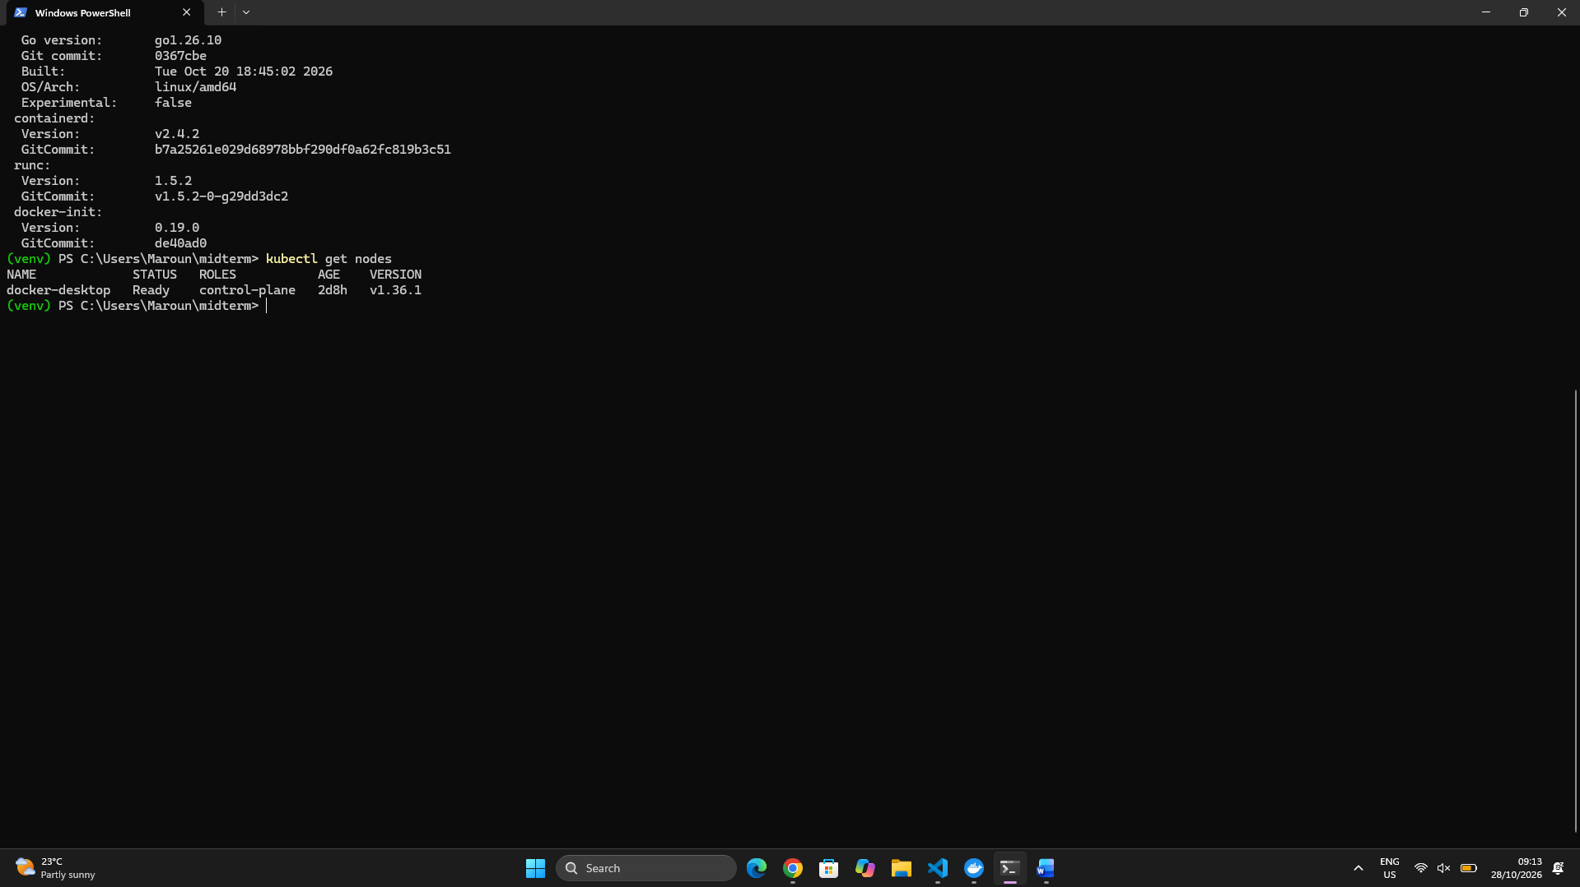

4- Separate storage per node
Four containers (node1 to node4), each with its own Docker volume mounted at /data, defined in docker-compose.storage.yml

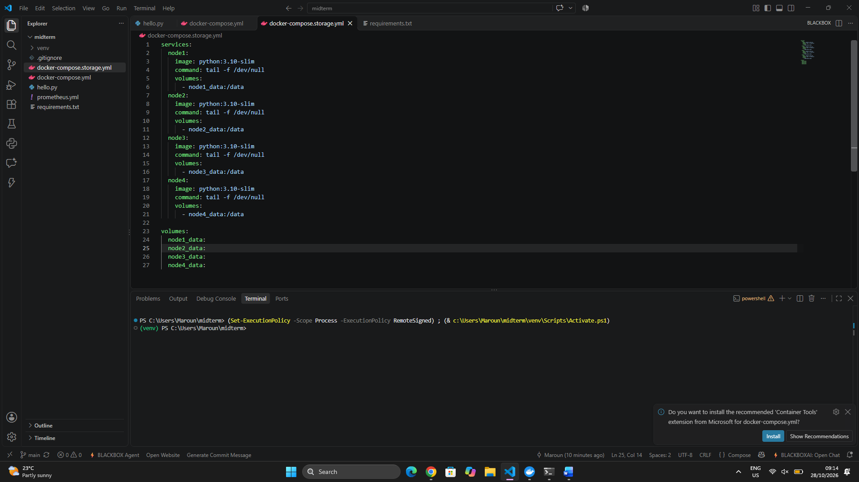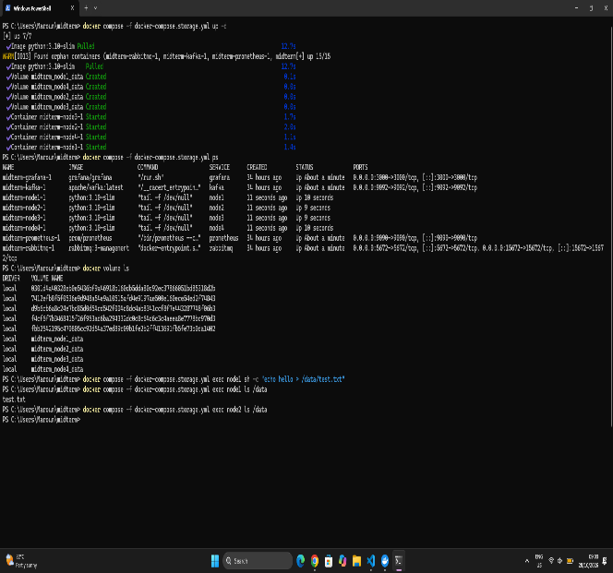

The environment is ready: Python, version control, Docker, Kubernetes, and four isolated storage nodes.

Task 2: Storage Node Module
1- Design
  - Each storage node is a FastAPI service exposing PUT, GET, HEAD and DELETE on /chunks/{hash}.
  - The chunk ID is the SHA-256 hash of its content. Chunks are stored on the node’s own volume at /data/<first 2 hex chars>/<hash>.
  - A small metadata service receives heartbeats and tracks which nodes are alive.
  - Files: storage_node/app.py, metadata_service/app.py, Dockerfile, docker-compose.storage.yml.
2- Deployment: 4 nodes in separate containers
- Built with docker compose -f docker-compose.storage.yml up -d --build.
- Each node has its own container, its own port (8001 to 8004) and its own volume from Task 1.
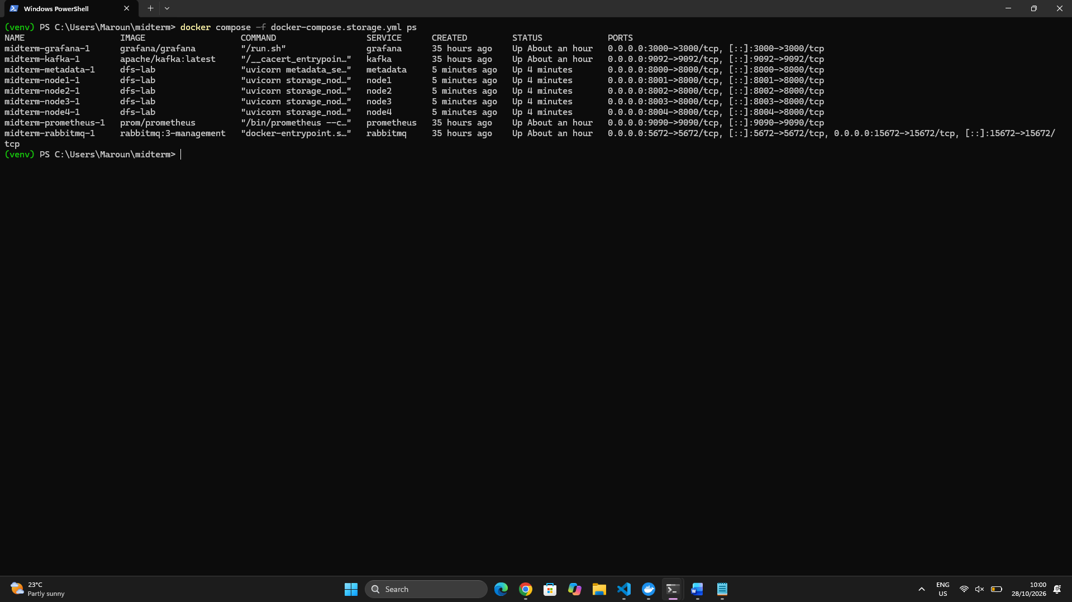

3- Heartbeats
- Every 5 seconds each node sends its node ID, free space and chunk count to the metadata service (POST /heartbeat).
- A node counts as dead if no heartbeat arrives for 15 seconds.
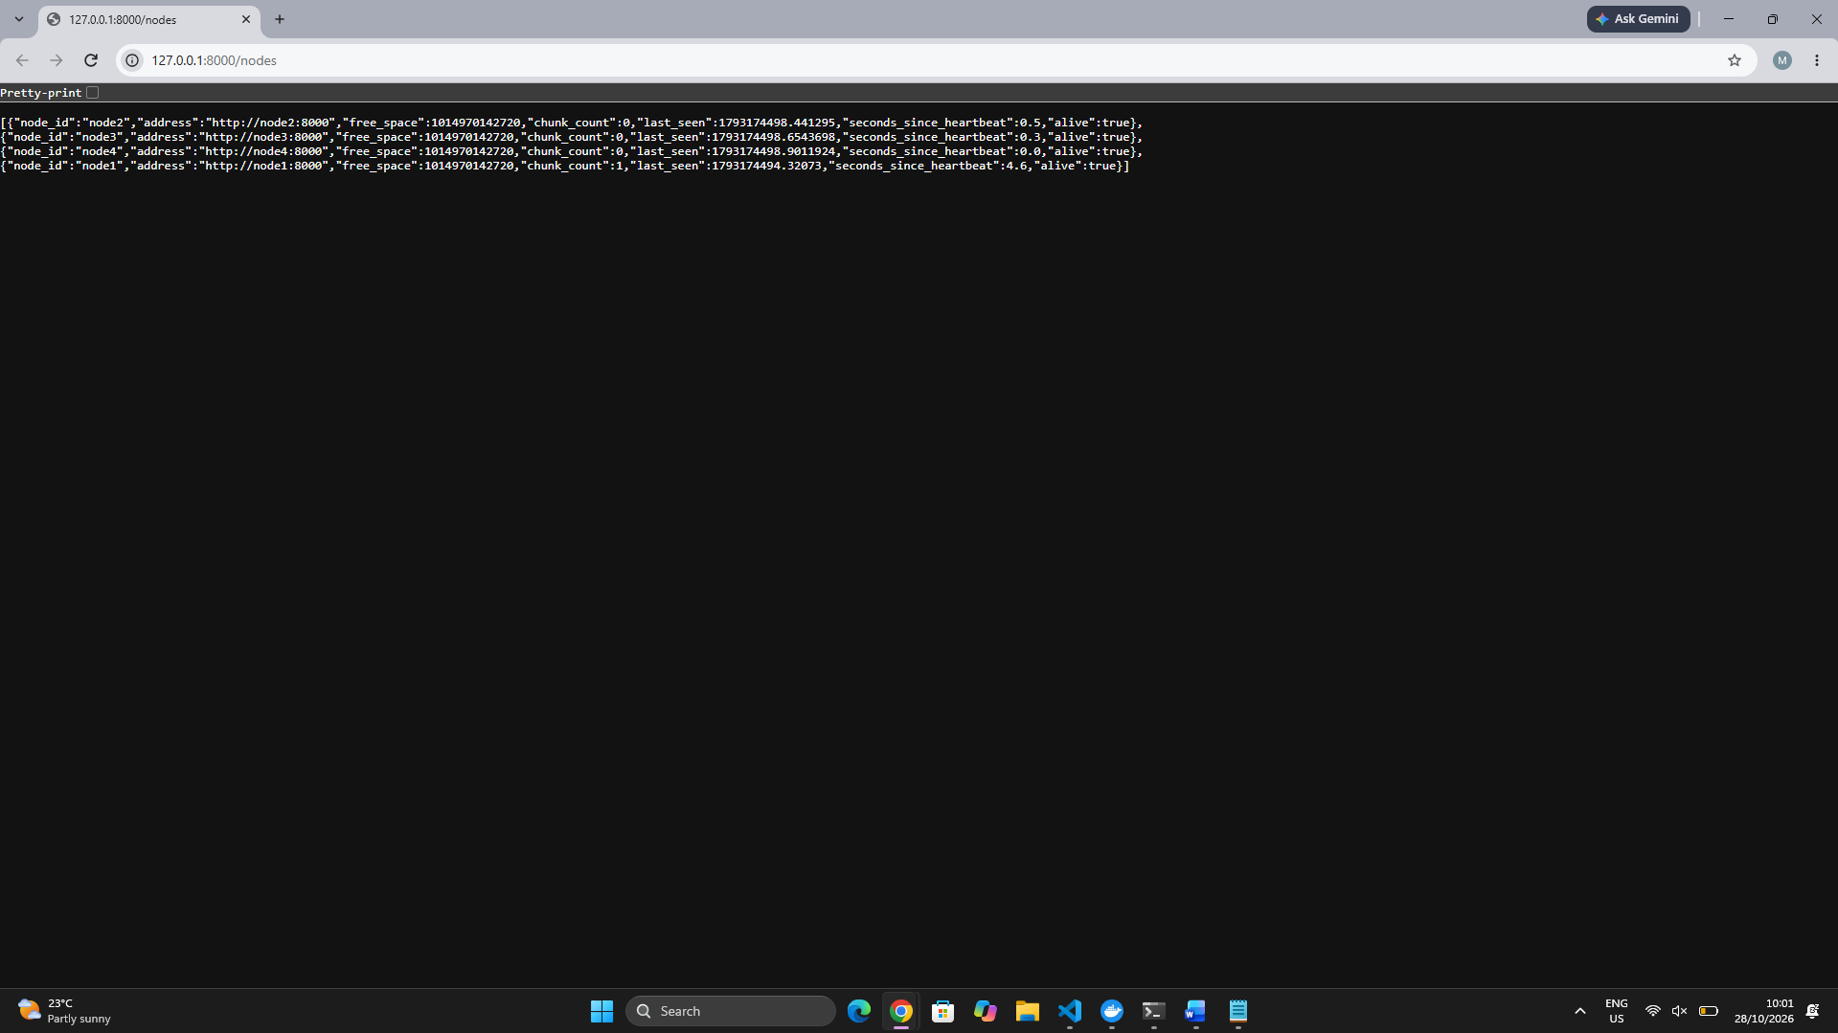

4- API test
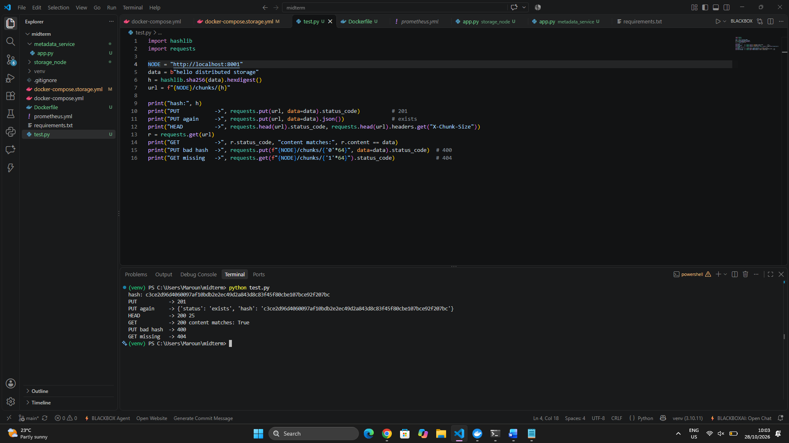

5- Integrity check on read
I modified a stored chunk on disk, and GET returned 500 chunk corrupted. The node re-hashes the data on every read and refuses to serve corrupted chunks.
Corruption test. Use the hash printed by the script, and replace HASH and HA (its first two characters):
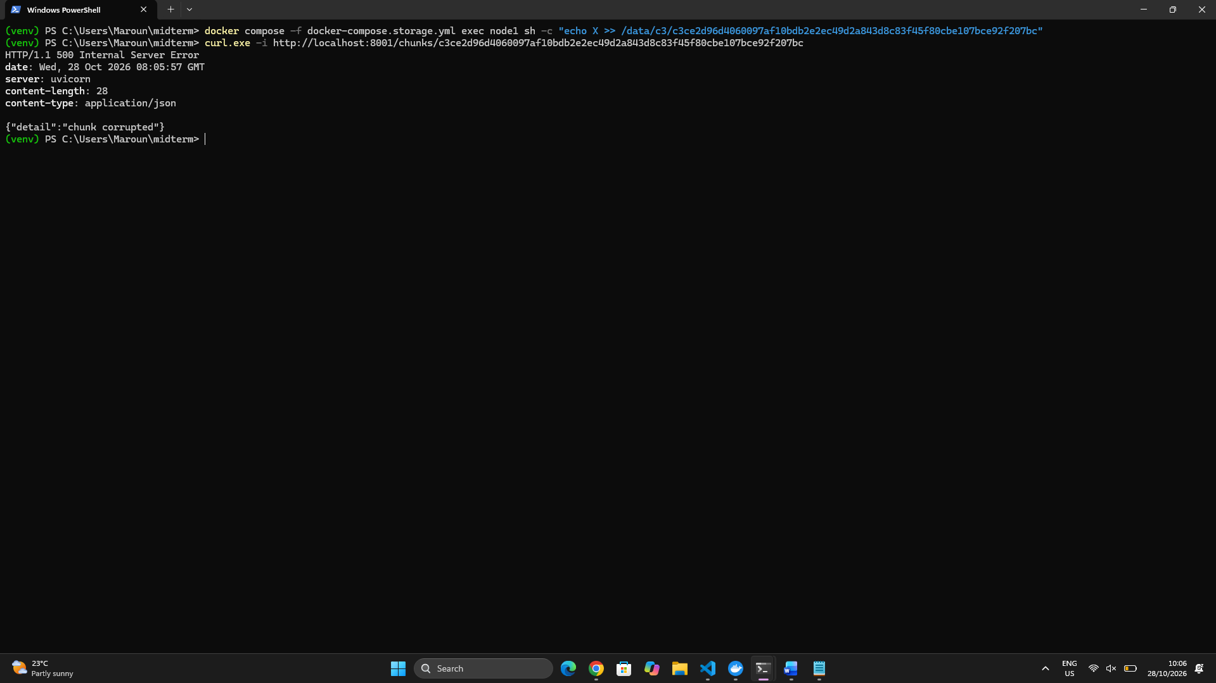

6- Delete
DELETE removed the chunk, and HEAD then returned 404.
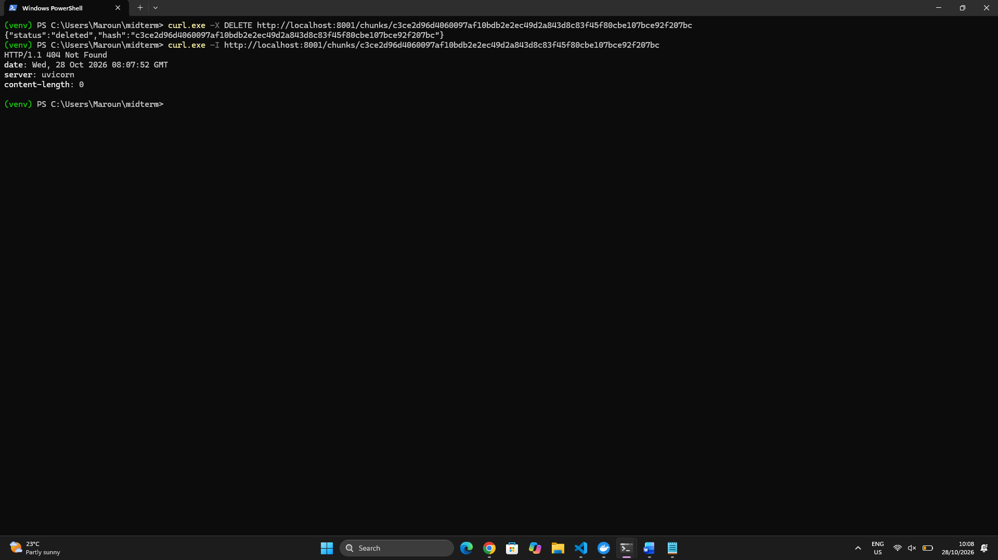
7- Failure detection
I stopped node3 with ‘docker compose -f docker-compose.storage.yml stop node3’. After 15 seconds it showed "alive": false in /nodes, and after starting it again it returned to true.

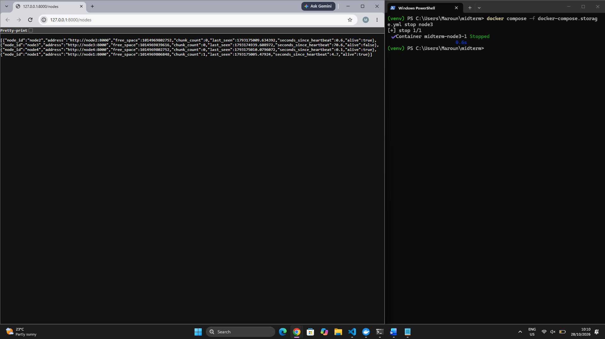

8. Challenge (optional but worth a short paragraph)
- The metadata container didn’t start at first, which made /nodes unreachable. I found the cause by checking docker compose ps -a and docker compose logs metadata, fixed it, and rebuilt. Short problems like this show real work.
Conclusion
Four independent storage nodes now store content-addressed chunks, verify integrity on every read, and report their health through heartbeats. This is the foundation for consistent hashing, replication and erasure coding in the next tasks.

Task 3: Implement the Metadata and Placement Module
1- Two strategies were implemented in metadata_service/chunking.py:
- Fixed-size chunking: the file is cut every 4 MB. It is simple and fast, but inserting even one byte at the start shifts every later boundary, so all chunks change.
- Content-defined chunking (CDC): a rolling (gear) hash is computed over the data, and a boundary is placed wherever the hash matches a bit pattern. Chunk sizes are between 16 KB and 256 KB, averaging about 64 KB. Boundaries depend on the content rather than the position, so a local edit only changes nearby chunks.

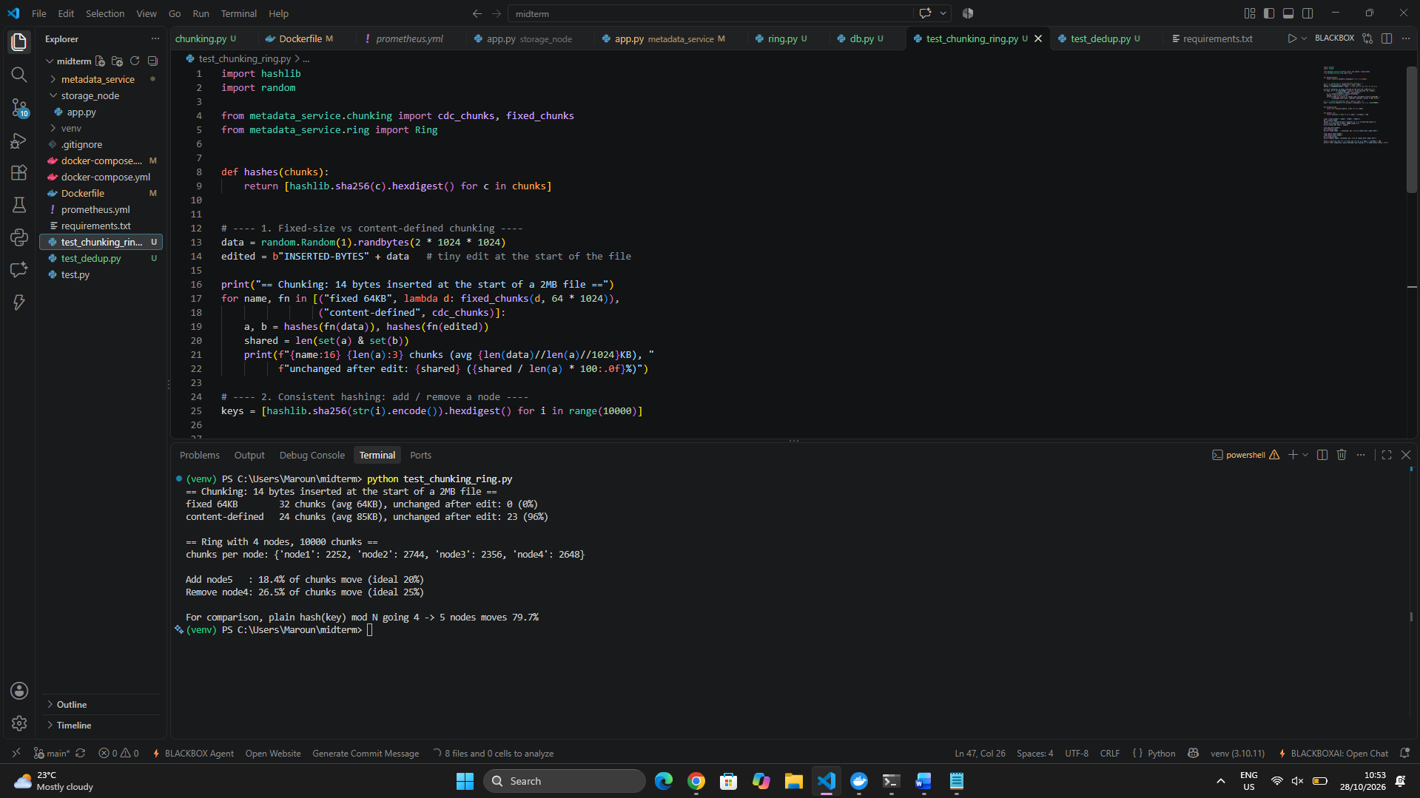

2- PostgreSQL runs as its own container, with a volume for its data. Two tables are used:
- objects: bucket, key, version, size, chunking mode, ordered list of chunk hashes (JSONB), creation date. The primary key is (bucket, key, version), so uploading the same key again creates a new version.
- chunk_refs: chunk hash, size, reference count, and the nodes that hold the chunk.

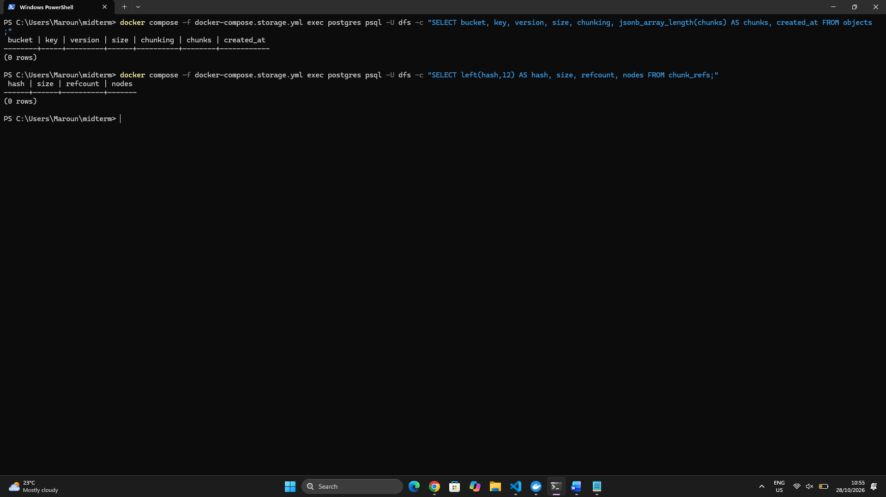

3- Implemented in metadata_service/ring.py. Each storage node is placed on the ring 100 times (virtual nodes) by hashing node#i with SHA-256. A chunk is mapped to the first 2 distinct nodes found clockwise from its hash, so each chunk has 2 replicas (REPLICAS=2). Virtual nodes spread the chunks evenly across nodes.
Distribution of primary placements with 4 nodes and 10,000 chunk hashes:
chunks per node: {'node1': 2252, 'node2': 2744, 'node3': 2356, 'node4': 2648}

4- The primary node assigned to each of 10,000 chunk hashes was recorded before and after changing the ring.
Change | Chunks that move | Ideal
Add node5 (4 to 5 nodes) | 18.4% | 20%
Remove node4 (4 to 3 nodes) | 26.5% | 25%
Plain hash mod N (4 to 5 nodes), for comparison | 79.7% | n/a

Explanation: with consistent hashing, a new node only takes over the ring segments right before its own points, so it takes a share of data roughly equal to 1/N from the others. With hash mod N, changing N changes almost every assignment, which would force nearly all the data to be moved. This is why consistent hashing scales.

5- Deduplication with reference counting.
Each chunk is identified by its SHA-256 hash. When a chunk is uploaded:
- If its hash is new, a chunk_refs row is created with refcount = 1 and the chunk is sent to its 2 target nodes.
- If the hash already exists, only the refcount is incremented, and nothing is sent to the nodes.
- On delete, the refcount is decremented, and the chunk is removed from the nodes only when it reaches 0.
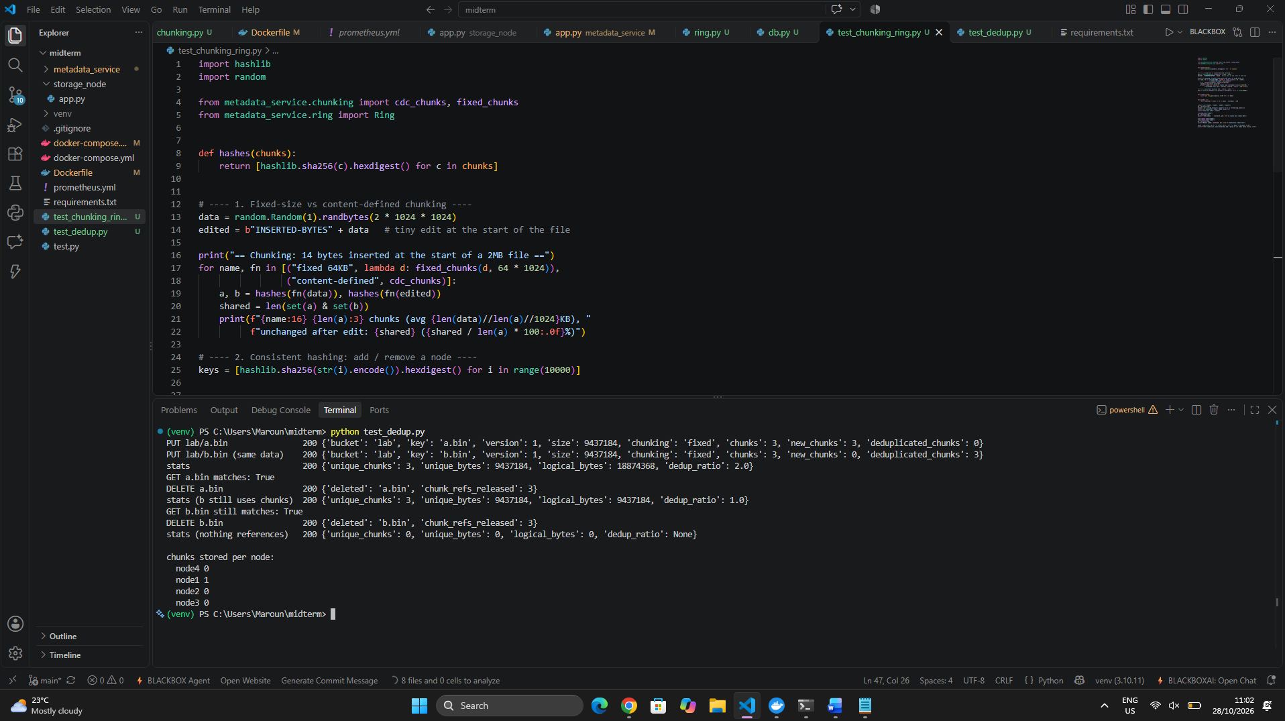

6- The system now splits files into chunks with fixed-size or content-defined chunking, stores object metadata and reference counts in PostgreSQL, places each chunk on 2 nodes using a consistent hashing ring with virtual nodes, and deduplicates identical chunks safely. The placement test showed that changing the number of nodes moves only a fraction of the data. Moving the data and repairing failed nodes will be done in the next task.

Task 4: Implement Redundancy and Recovery
1- Environment preparation
- Added zfec to the Dockerfile.
- Extended the metadata service with the replication settings (N=3, W=2, R=2) and the erasure-coding settings (k=2, m=2).
- Rebuilt the images and reset the volumes, so the test starts from an empty cluster.
- The /nodes output shows four storage nodes alive with zero chunks.

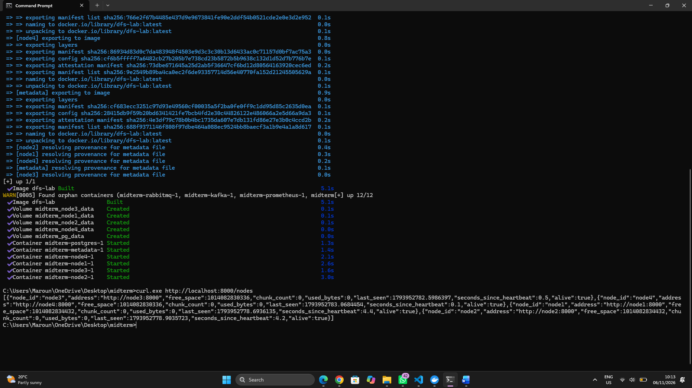

2- Redundancy configuration
- Redundancy is configured with environment variables in the metadata service.
- ec.py wraps zfec: encode() cuts a chunk into k data shards and adds m parity shards, and decode() rebuilds the chunk from any k shards.
- Each bucket has a mode, replication or ec, stored in a new buckets table.
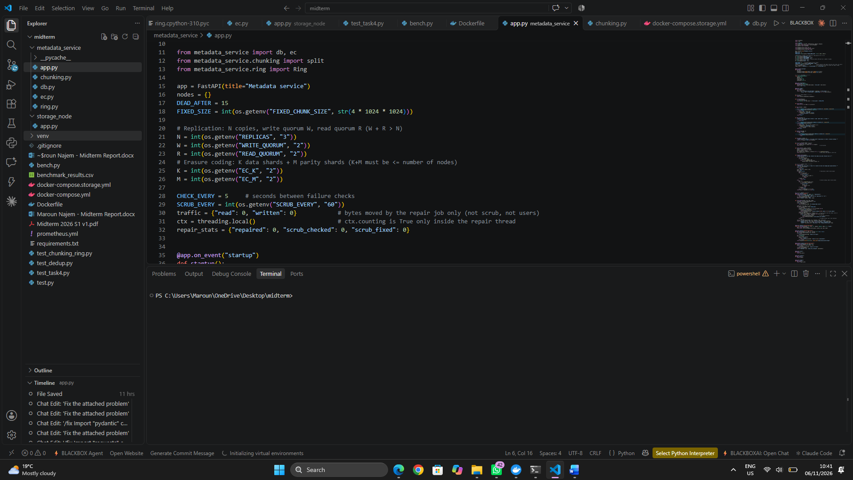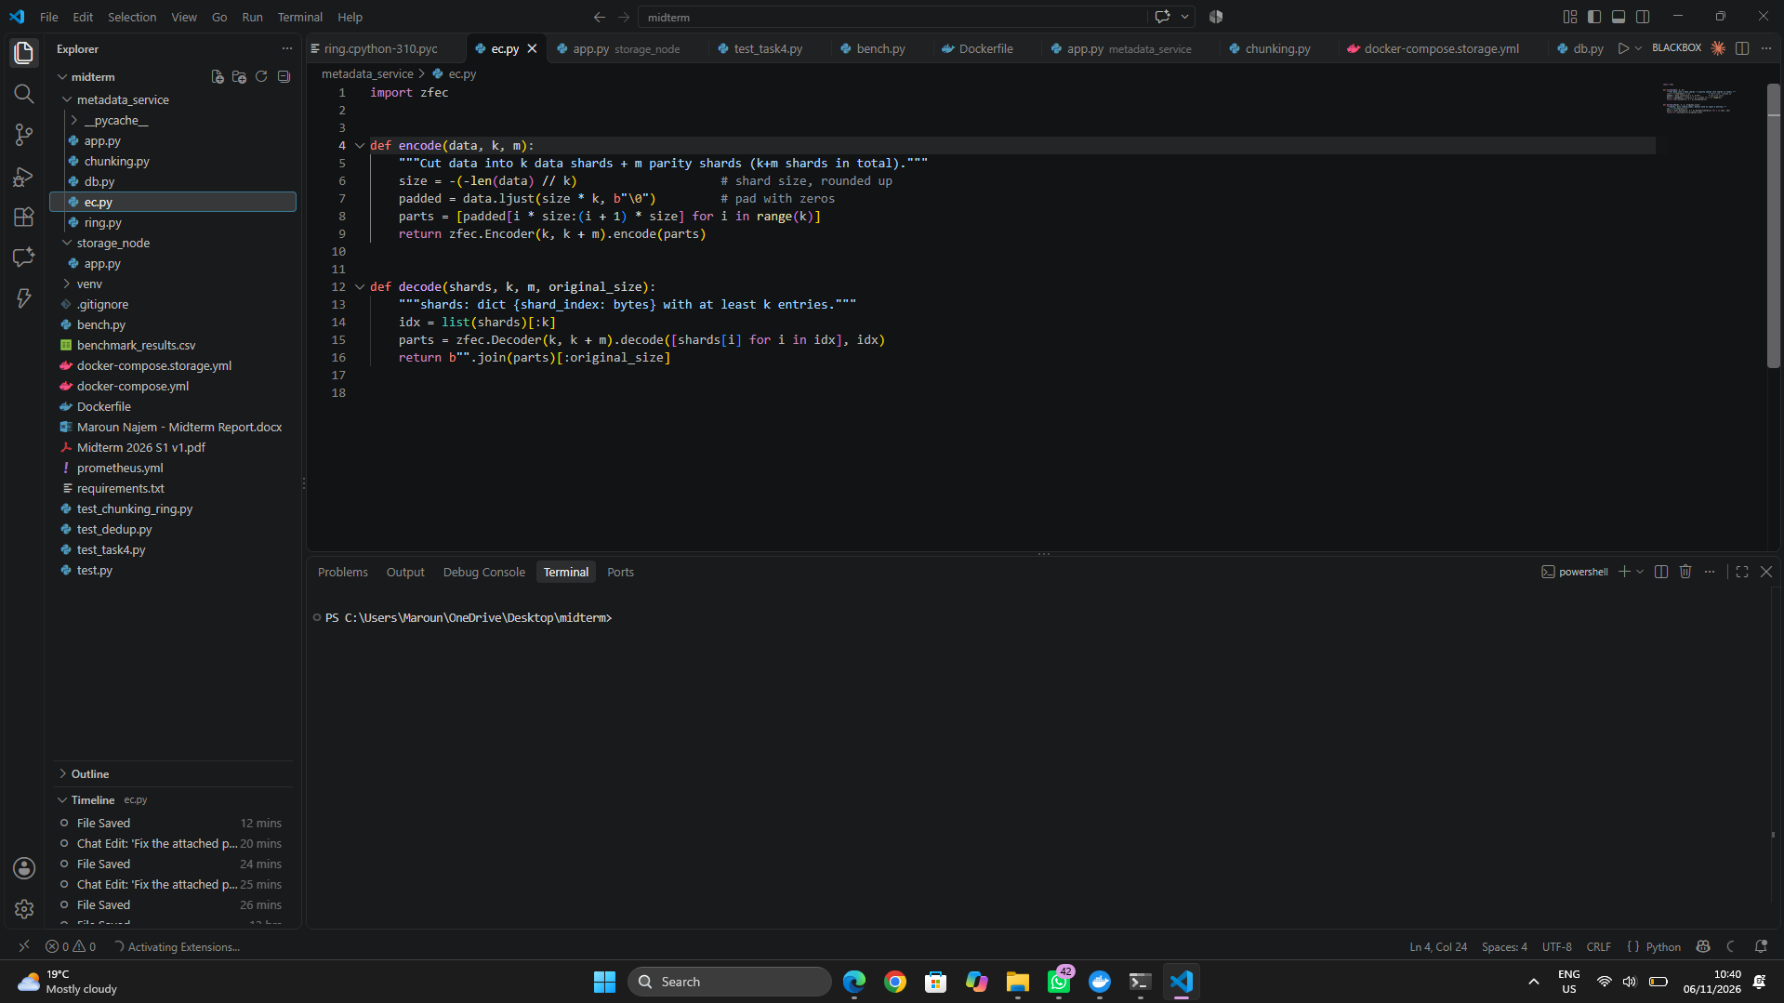

3- Upload to a replicated and an erasure-coded bucket
- I created one bucket per mode and uploaded a 9 MB object (3 chunks) to each.
- Replication bucket: each chunk is written to 3 nodes, and the write succeeds once 2 acknowledge (W=2).
- EC bucket: each chunk is encoded into 4 shards, one per node, and the write succeeds once 3 are stored.
- The nodes hold 47.2 MB for 18.9 MB of logical data, which is 3x for the replicated object and 2x for the EC object.

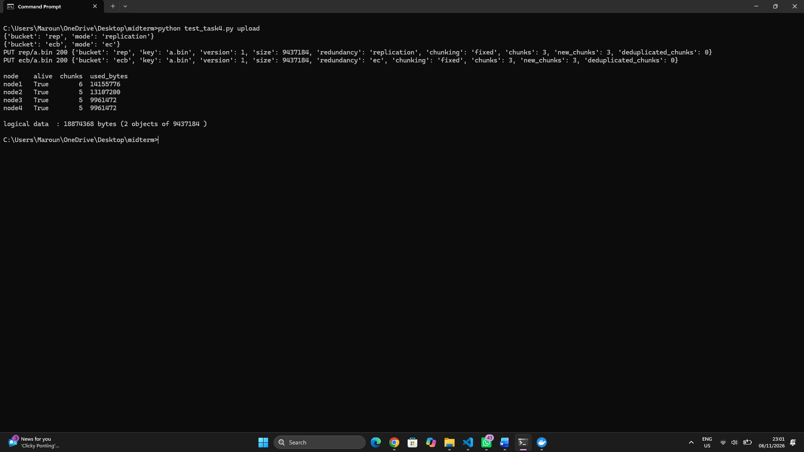

4- Reading data back
- A read fetches R=2 valid copies per chunk (replication) or any 2 valid shards and decodes them (EC).
- Every piece is re-hashed with SHA-256 and rejected if it doesn’t match.
- Both objects are identical to the originals (matches: True).\

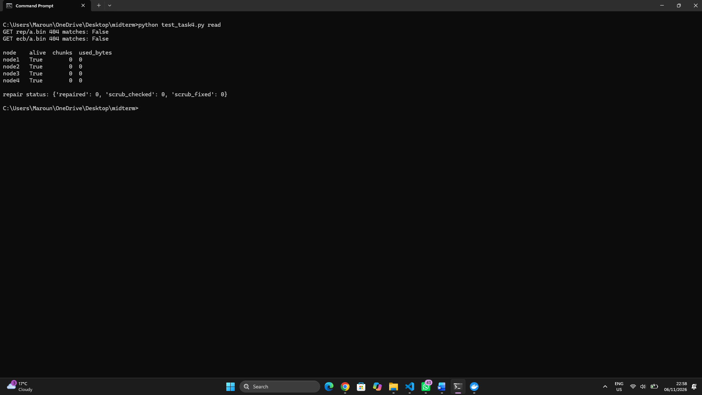

5- Node failure and repair
- I stopped node3. After 15 seconds without a heartbeat, the metadata service marks it as failed.
- Reads remain correct because 2 of 3 copies and 3 of 4 shards survive.
- A repair job then rebuilt the 5 chunks and shards that were on node3 onto the remaining nodes (repaired: 5), and the chunk counts of nodes 1, 2 and 4 grew accordingly.
- Full redundancy was restored without manual action.

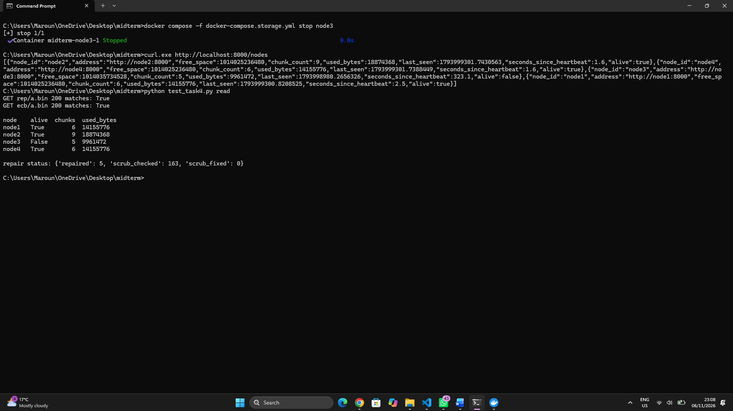

6- Scrubber
- I corrupted a chunk on node1 by appending a byte. A direct GET returned 500 chunk corrupted, because the node verifies the hash on every read.
- The background scrubber runs every 60 seconds, and I also triggered it manually.
- It re-read every chunk, detected the mismatch, deleted the bad file and rewrote it from a healthy copy. The same GET then returned 200.
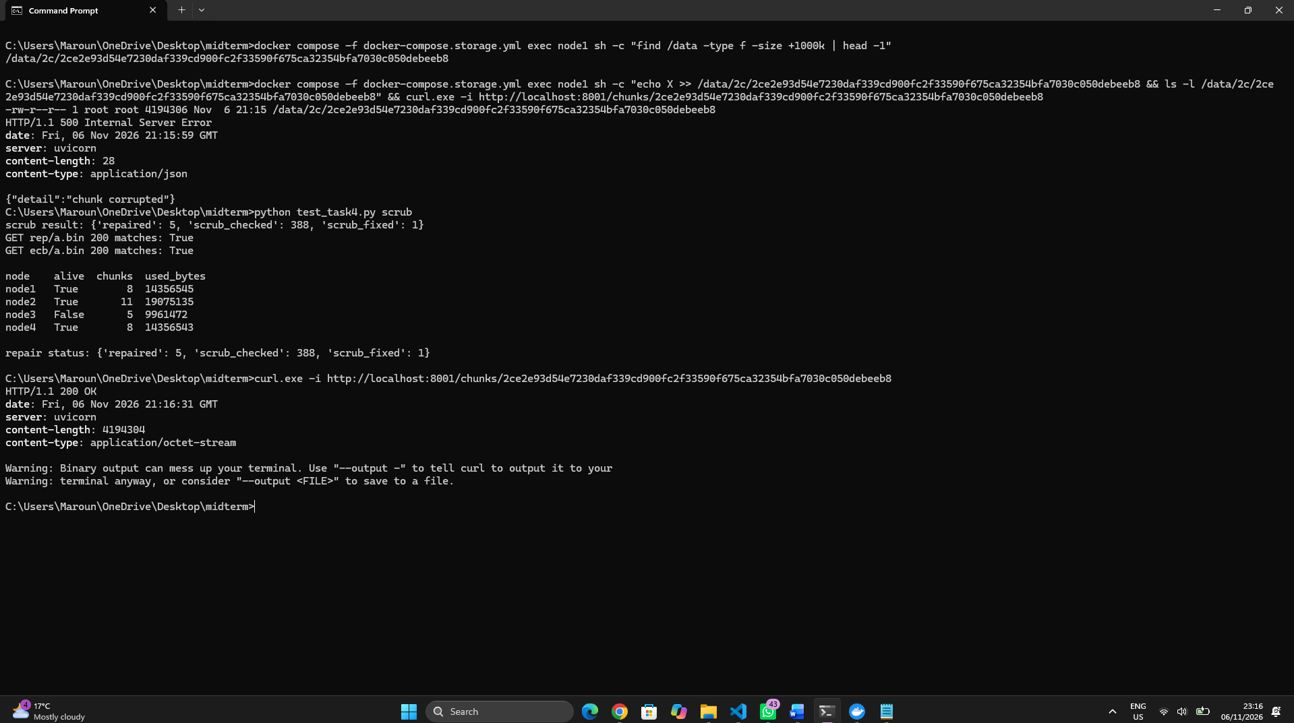

7- Benchmark: replication vs erasure coding
- I wrote a benchmark script, bench.py, that runs both workloads in both modes: 5,000 files of 1–50 KB (130.1 MB in total) and 10 files of 100 MB (1,048.6 MB).
- For each combination the script uploads the data, measures the bytes stored on all nodes, stops node3, measures the bytes moved by the repair job until the repair finishes, and then cleans up.
- The scripts that generate the datasets are part of bench.py.

Workload | Mode | Stored | Overhead | Repair traffic | Upload time | Repair time
Small (5,000 files) | Replication 3x | 390.4 MB | 3.0x | 297.0 MB | 293.6 s | 168.2 s
Small | Erasure coding 2+2 | 260.3 MB | 2.0x | 195.2 MB | 314.7 s | 214.4 s
Large (10 files) | Replication 3x | 3,145.7 MB | 3.0x | 2,403.3 MB | 58.2 s | 39.4 s
Large | Erasure coding 2+2 | 2,097.2 MB | 2.0x | 1,572.9 MB | 63.4 s | 23.2 s

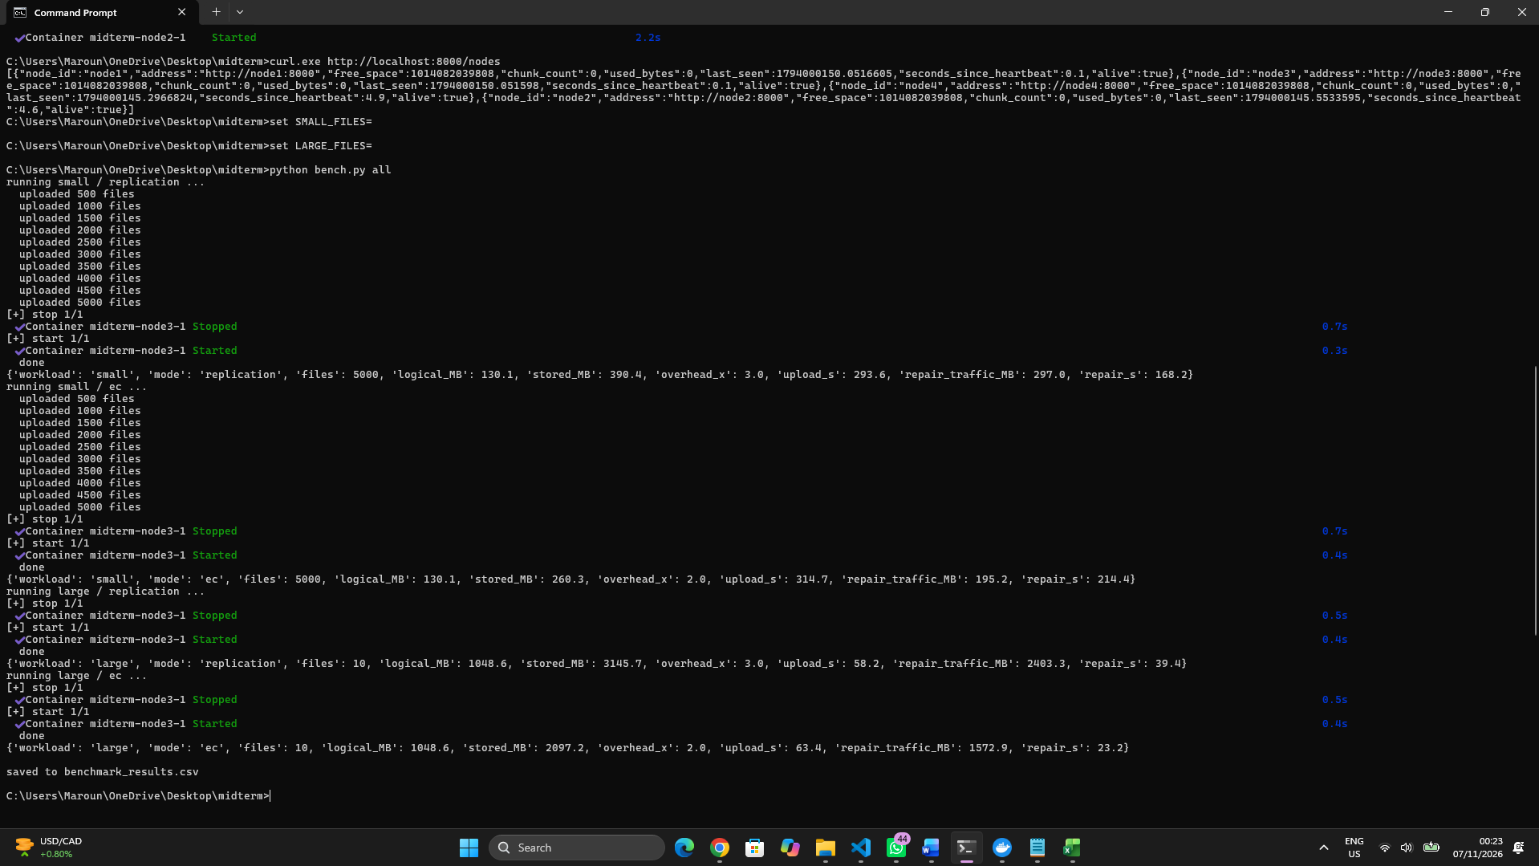



- Storage overhead: replication stores 3x the logical data and erasure coding 2+2 stores 2x, so erasure coding saves a third of the disk space on both workloads.
- Repair traffic: erasure coding moved about 34% less data to repair the failed node on both workloads (195 vs 297 MB, and 1,573 vs 2,403 MB). Replication reads 2 full copies and writes 1 copy for each lost chunk, so the traffic is about 2.25x the logical data (node3 held about three quarters of the chunks). Erasure coding reads 2 half-size shards and writes 1, which is about 1.5x.
- Performance cost: erasure coding needs CPU time to encode and decode, and it sends 4 shards per chunk instead of 3 copies. Uploads were about 7% slower for the small files and 9% slower for the large files. For the large files erasure coding repaired faster (23 s vs 39 s) because it moves less data, but for the small files it was slower (214 s vs 168 s), because thousands of tiny chunks each need several requests plus encoding. Times vary between runs, so the conclusions are based on the byte counts, which were identical across runs.
- Fault tolerance: with all 4 shards stored, erasure coding 2+2 can survive 2 simultaneous node failures because any 2 of the 4 shards are enough to rebuild a chunk. The write operation succeeds after 3 shards are acknowledged, so at that point it can tolerate 1 additional node failure. Replication with all 3 copies stored can survive 1 node failure when the read quorum is 2; if only 2 copies have been acknowledged, it cannot tolerate another copy loss.
8- Challenges and limitations
- Scrub traffic counted as repair traffic: my first benchmark showed repair traffic about double the expected value, because the scrubber’s reads were counted. I changed the counter so it only counts the repair thread, and the values then matched the theory.
- Heartbeat thread dying: when a node counted its file sizes for the heartbeat while the benchmark was deleting thousands of chunks, a file could disappear mid-count, and the error stopped the heartbeat thread, so the node was wrongly considered dead. I made the counting skip deleted files and made the heartbeat loop survive any error.
- Old copies on a returning node: a node that comes back after a failure keeps its old copies, which would falsify the next storage measurement, so the benchmark now refuses to run unless the cluster is empty. Removing these stale copies is a garbage-collection job, which belongs to the bonus tasks.
- Quorum reads: a replicated chunk needs 2 valid copies to be read, so if two nodes fail at the same time before the repair runs, reads of that chunk fail until the repair finishes.
Conclusion
Replication is simpler and faster for small objects, but it costs more space and more repair traffic. Erasure coding is better for large data and for storage cost, at the price of CPU time, slower small-file repair and a minimum number of nodes.

Task 5: Develop the API for Data Access
1- Gateway service
- I created a FastAPI gateway service in gateway/app.py and gateway/auth.py. Users only talk to the gateway, and it forwards each request to the metadata service.
- The gateway runs in its own container on port 8080, next to the metadata service, PostgreSQL and the 4 storage nodes. It is defined in docker-compose.storage.yml and uses the same Python image, to which httpx was added.
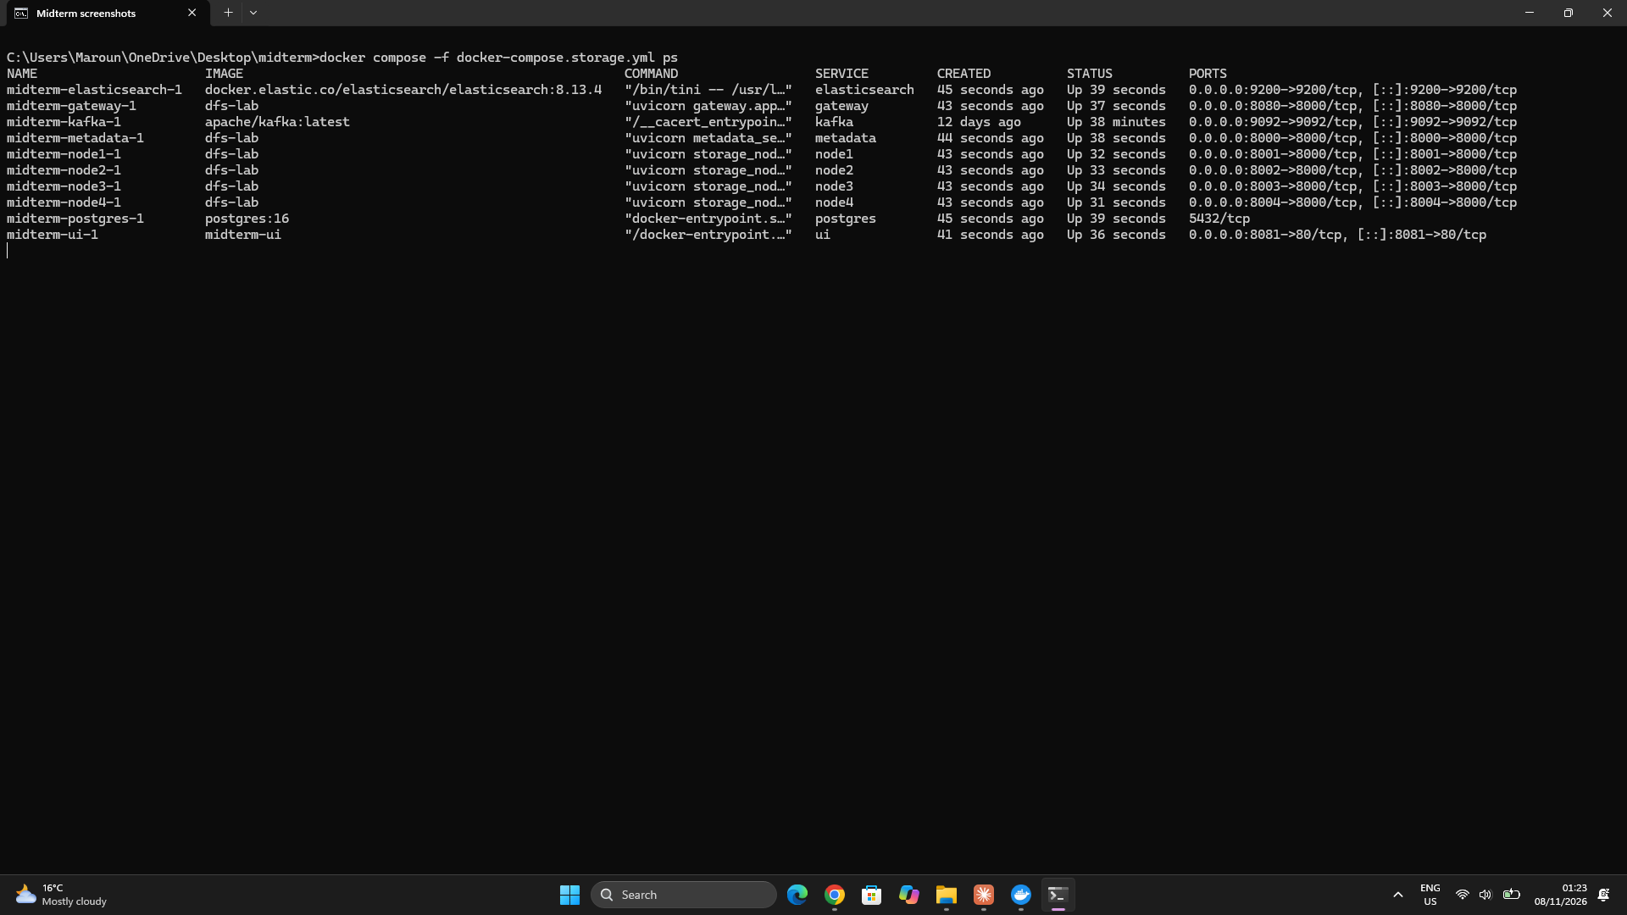

2- Authentication
- Every endpoint requires an API key in the X-API-Key header. The valid keys come from the API_KEYS variable.
- A missing or wrong key returns 401 Invalid or missing API key, and a valid key returns 200.
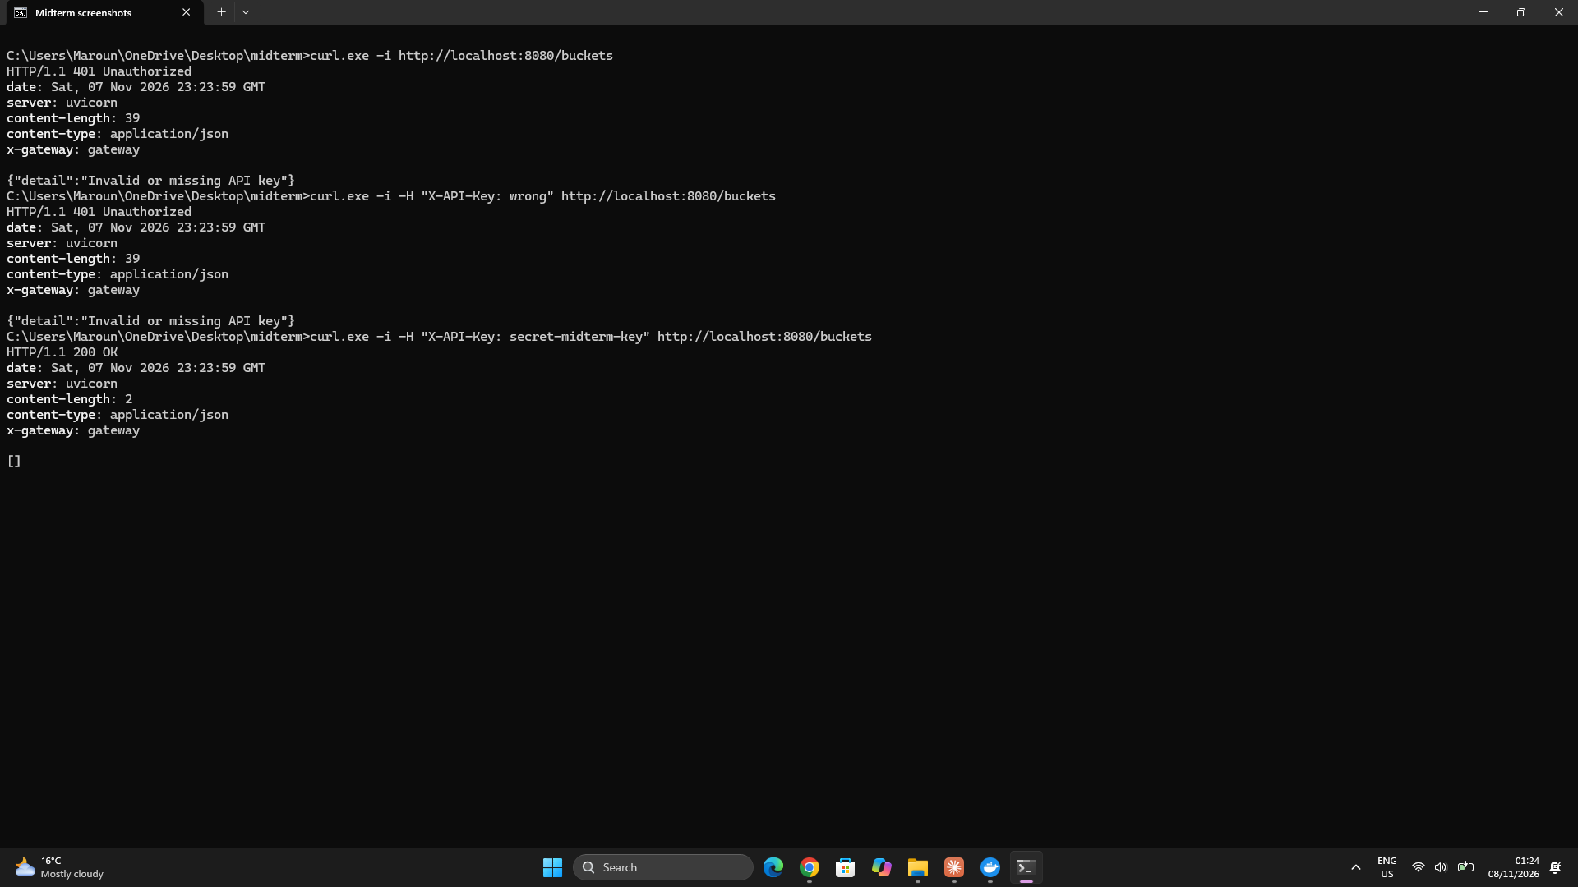

3- Creating and listing buckets
- POST /buckets/{name} creates a bucket. The mode parameter chooses replication (the default) or ec (erasure coding).
- GET /buckets lists the buckets with their mode.
- I created photos with replication and archive with erasure coding, then listed them.
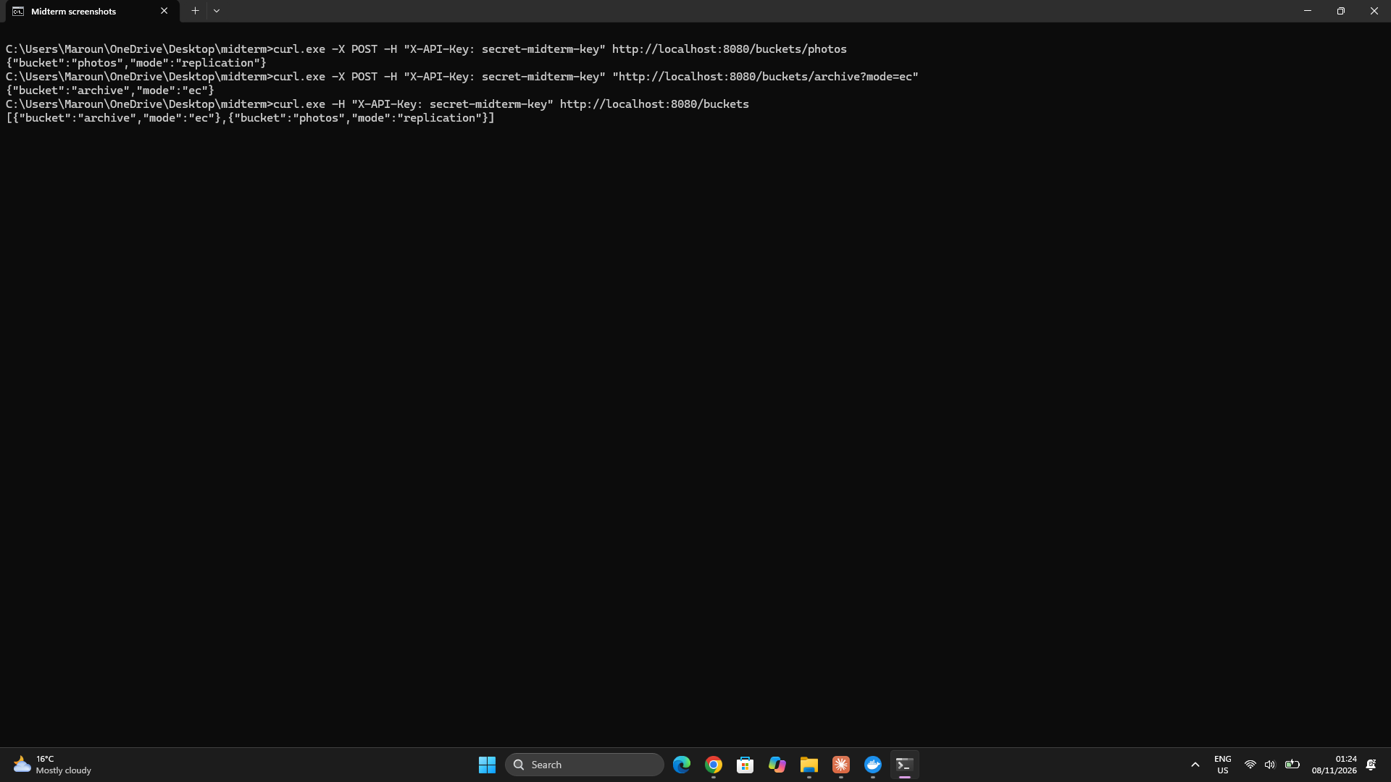

4- Uploading objects with streaming
- PUT /buckets/{bucket}/objects/{key} uploads an object. The gateway forwards the request body to the metadata service as a stream. However, the current metadata endpoint reads the complete body into memory before splitting it into chunks. Fixed-size chunking uses 4 MB chunks by default; content-defined chunking can be selected with mode=cdc. Therefore, the request is streamed to the gateway, but chunk processing is not fully incremental at the metadata service.
- User-defined tags are sent as tag=key:value parameters and stored with the object.
- I uploaded a small file with two tags, then the 50 MB file big.bin, which was split into 13 chunks.
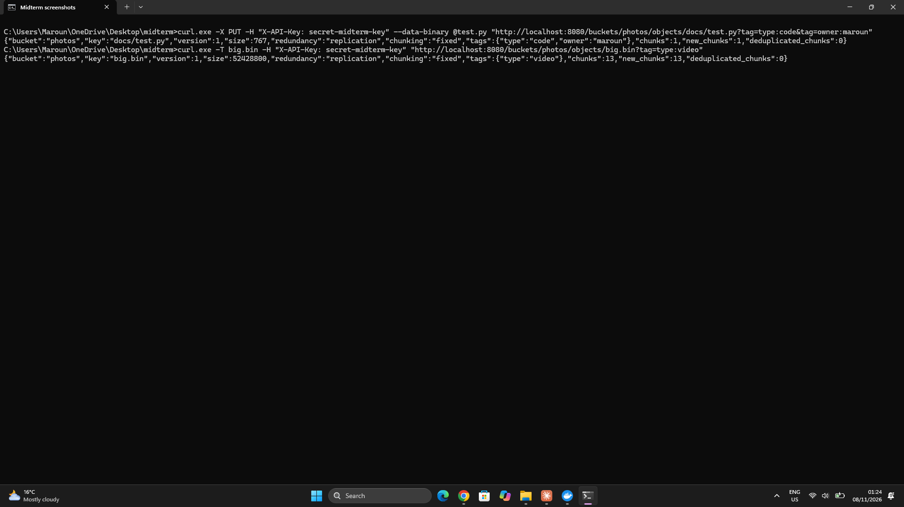

5- Downloading objects
- GET on the same path returns the whole object, rebuilt from its chunks.
- The downloaded copy of big.bin is identical to the original: fc /b reports no differences.
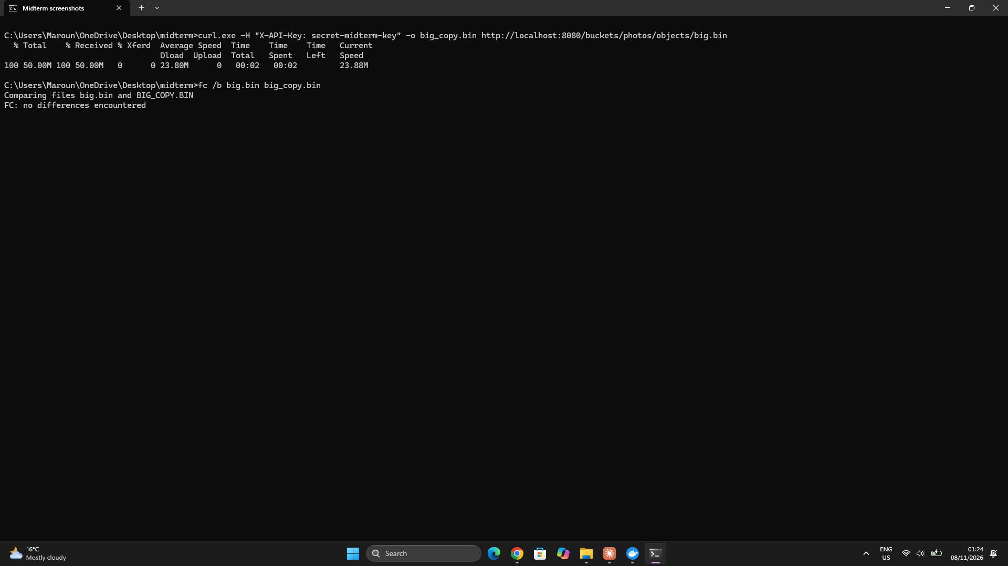

6- Byte-range requests
- With a Range header, for example bytes=0-99, or bytes=-50 for the last 50 bytes, the gateway returns 206 Partial Content with a Content-Range header. A range outside the object returns 416.
- Only the chunks that overlap the range are read from the storage nodes.
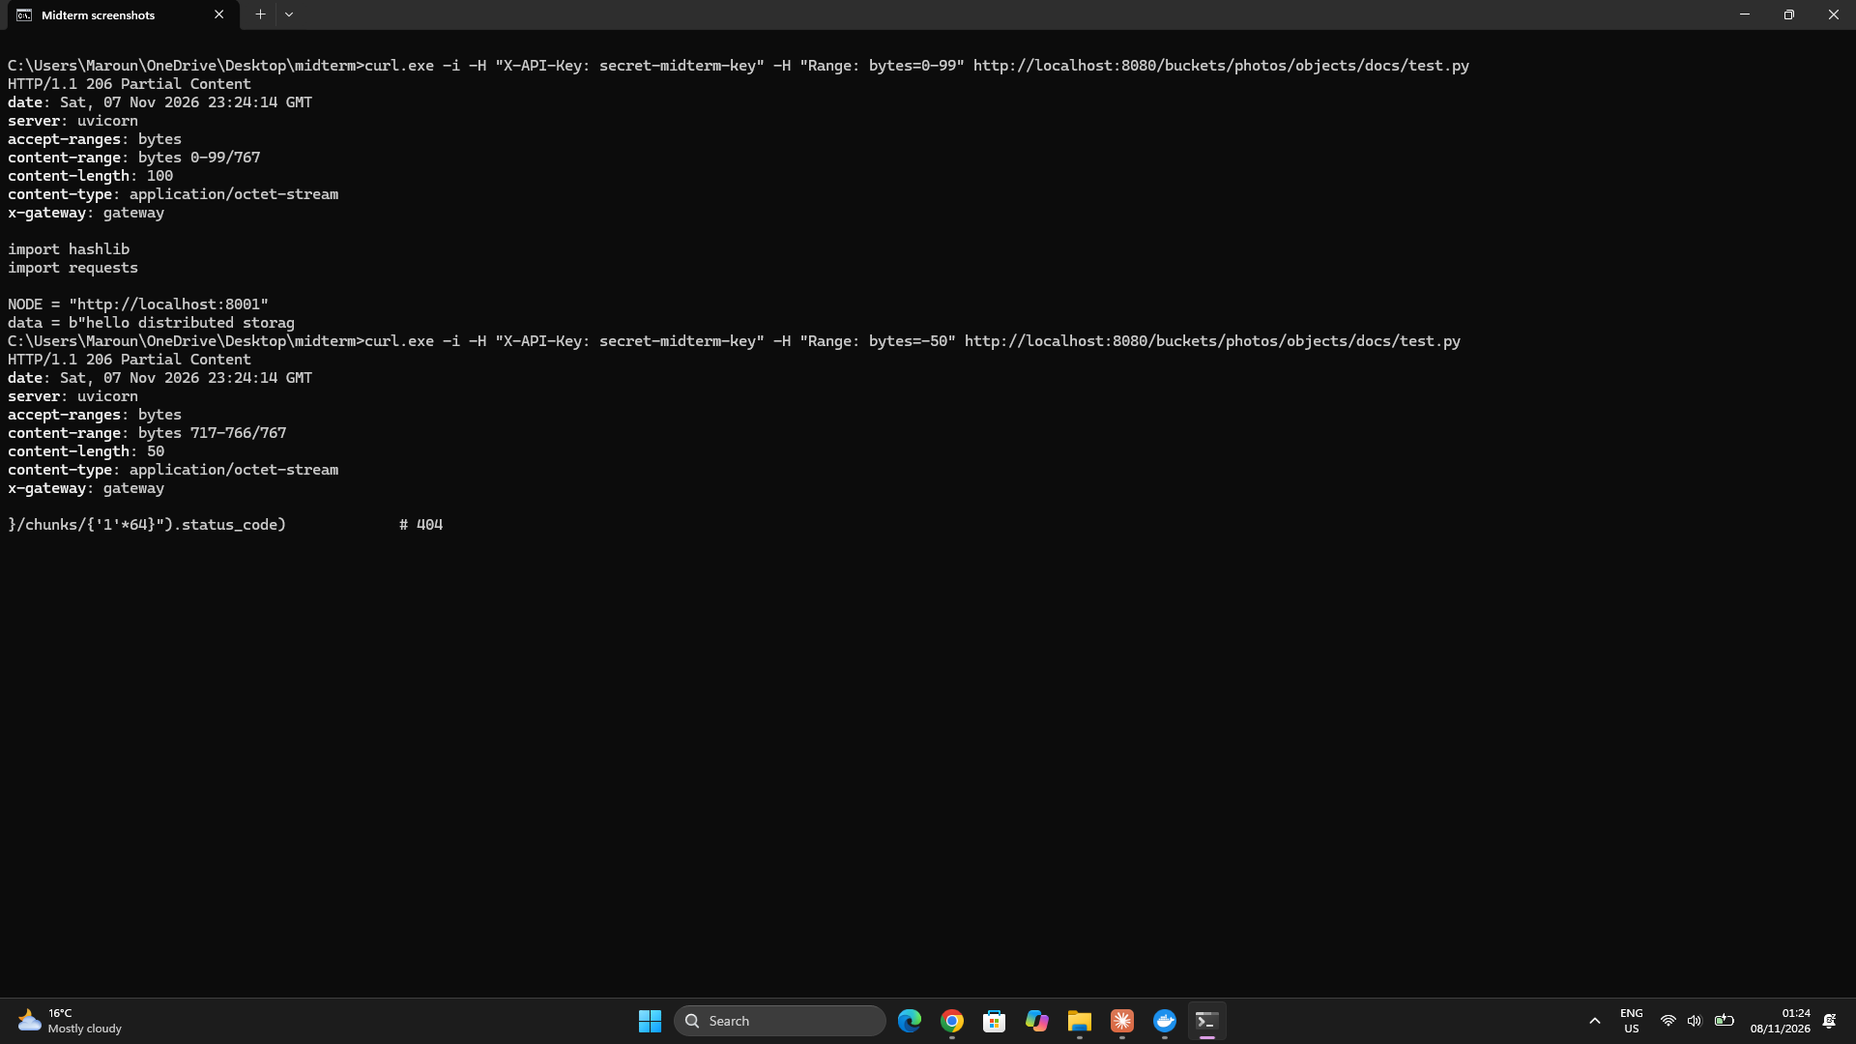

7- Object metadata
- GET /buckets/{bucket}/metadata/{key} returns the size, version, chunking mode, creation date, tags and the ordered list of chunk hashes of the object.
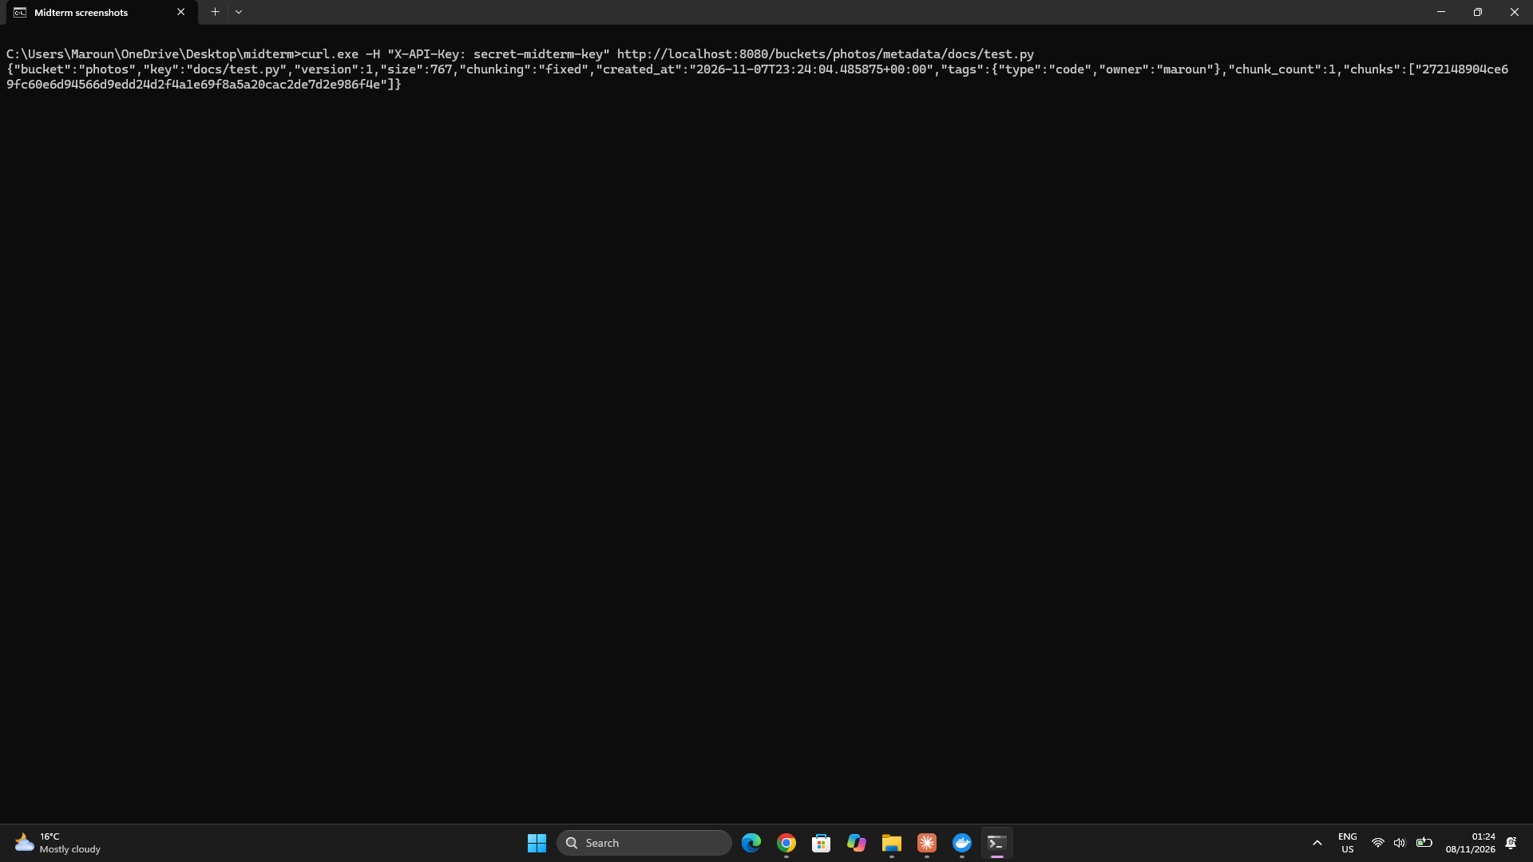

8- Listing and searching objects
- GET /buckets/{bucket}/objects lists the latest version of every object in the bucket.
- The list can be filtered by key prefix (prefix), size (min_size and max_size), date (after and before) and tags (tag=key:value), and the filters can be combined. The search runs in PostgreSQL.
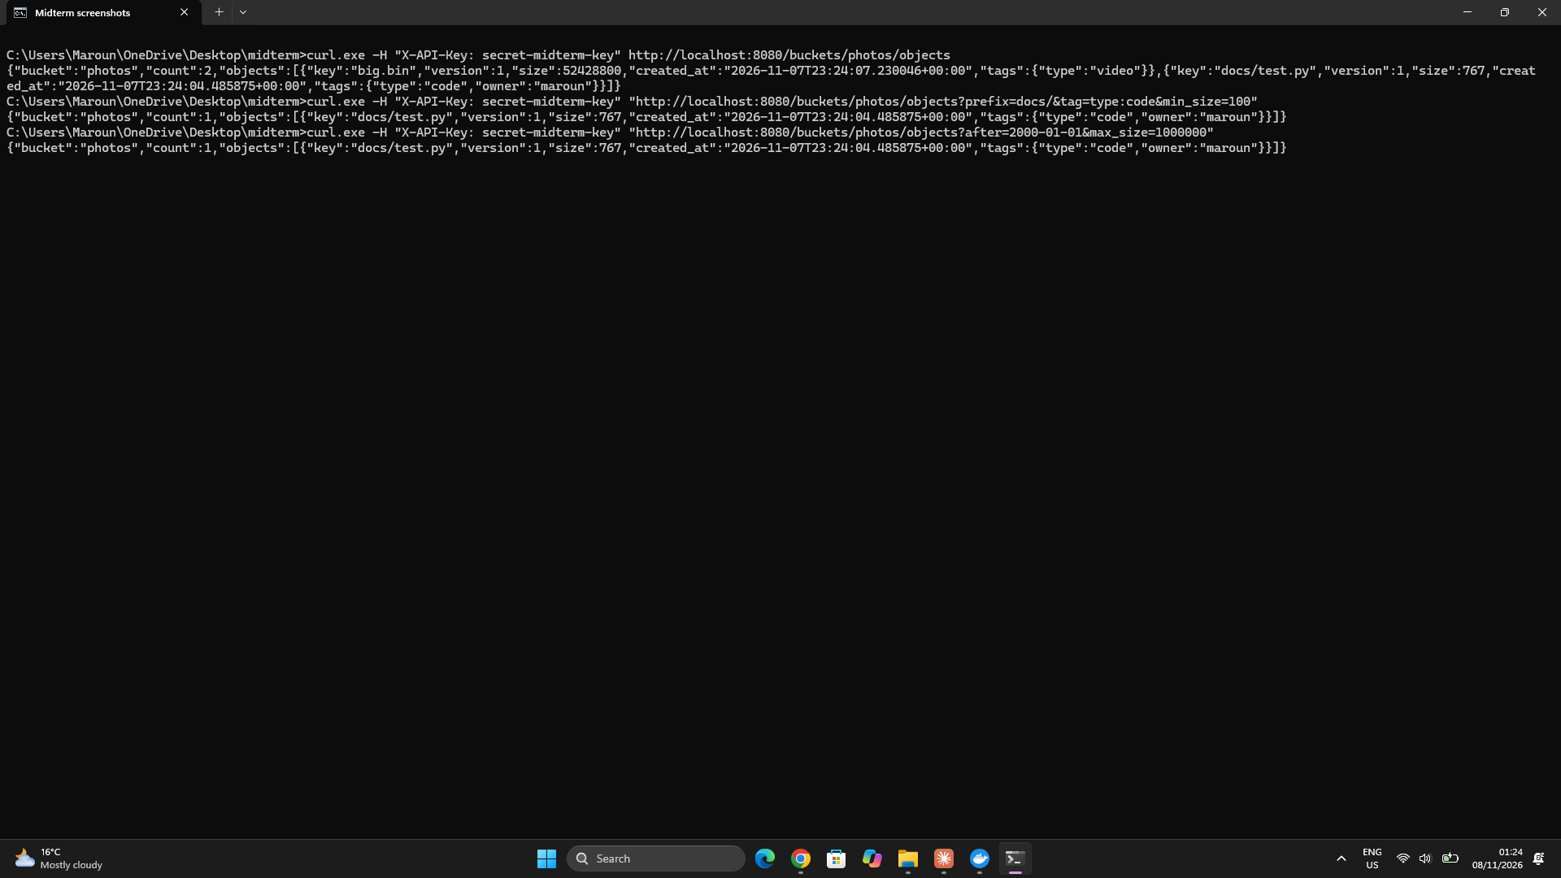

9- Deleting objects
- DELETE /buckets/{bucket}/objects/{key} deletes every version of the object, and a GET then returns 404.
- The chunks are released through the reference counting from Task 3, so they are only removed from the nodes when no other object uses them.
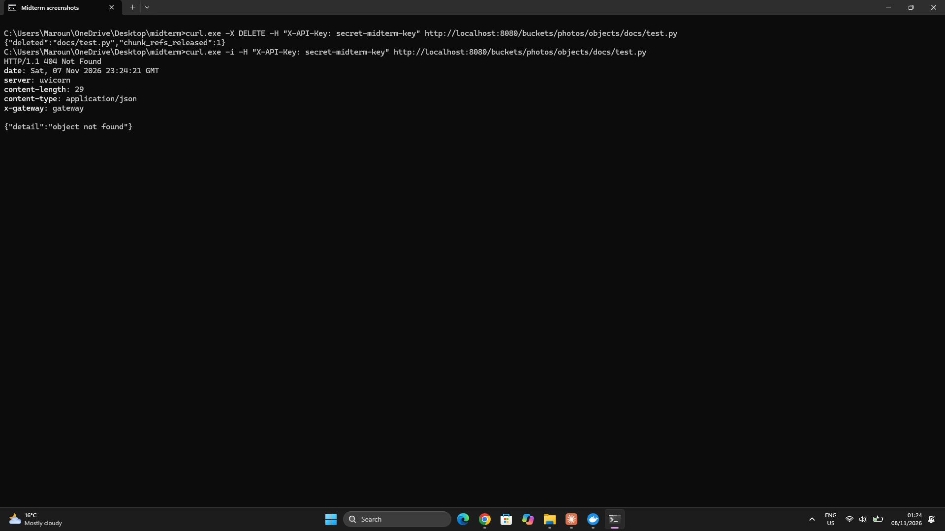

10- Cluster status
- GET /cluster/status reports, for each node, its health, free space, chunk count and used space. It also reports the number of alive and dead nodes, and the number of degraded chunks and degraded objects, meaning those with a copy or shard on a dead node.
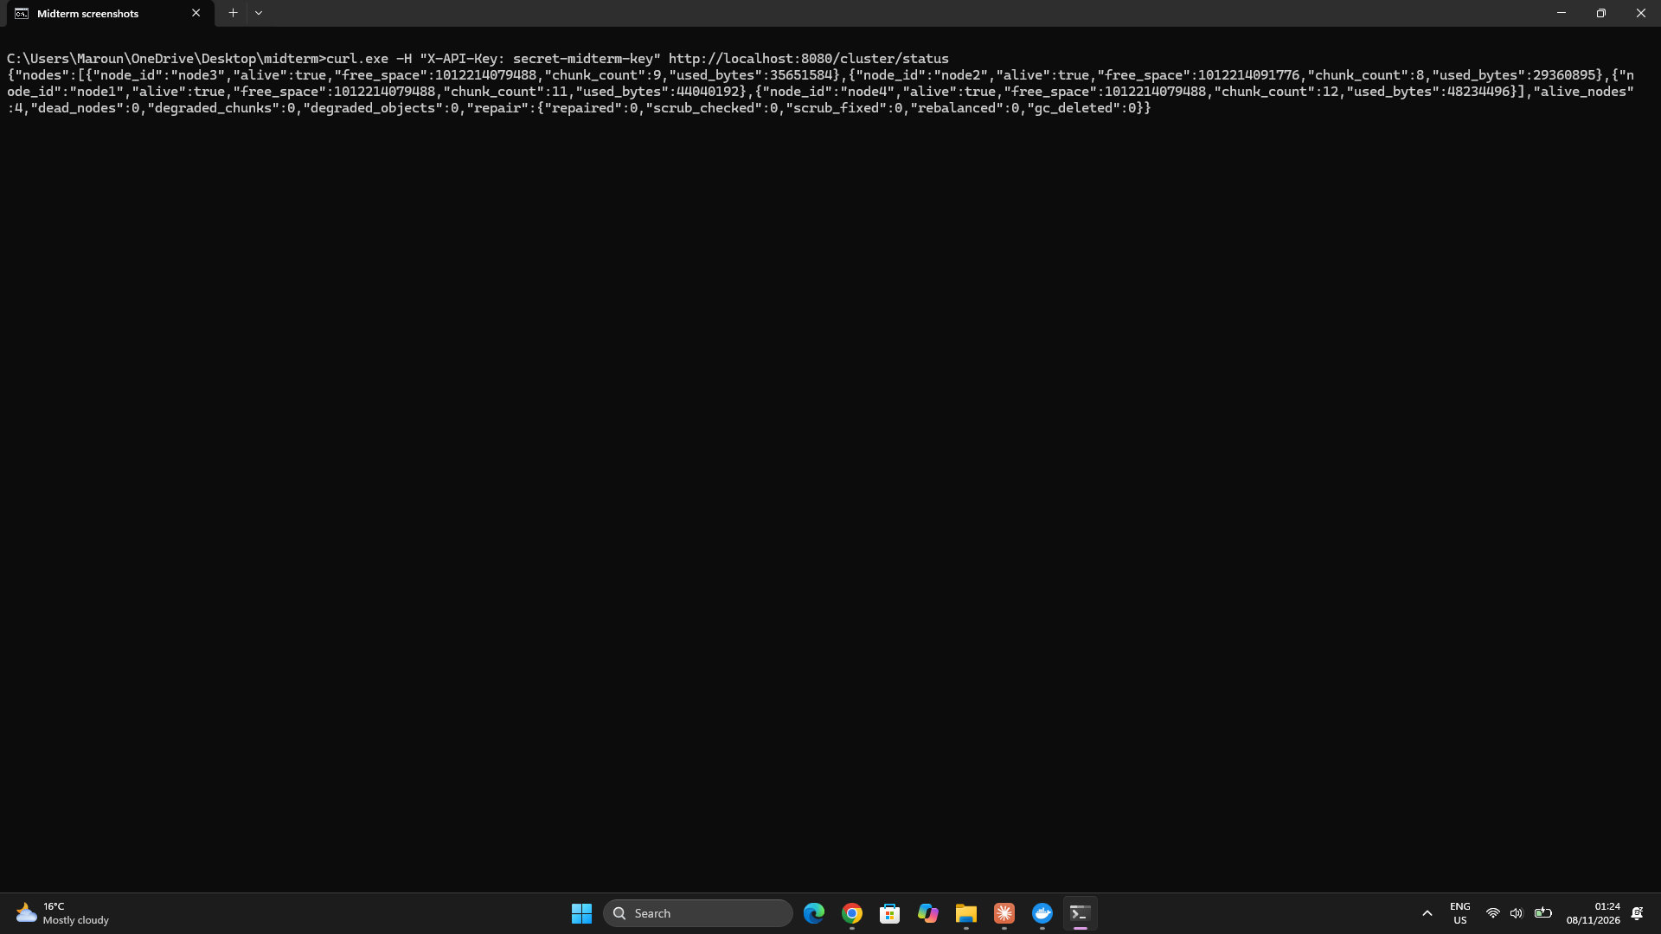

11- Rate limiting
- Each API key may send 100 requests per minute (the RATE_LIMIT variable). Further requests return 429 Too Many Requests, with a Retry-After header giving the number of seconds to wait.
- I sent 110 requests in a row with the key rate-test-key. The first 100 returned 200 and the rest returned 429.
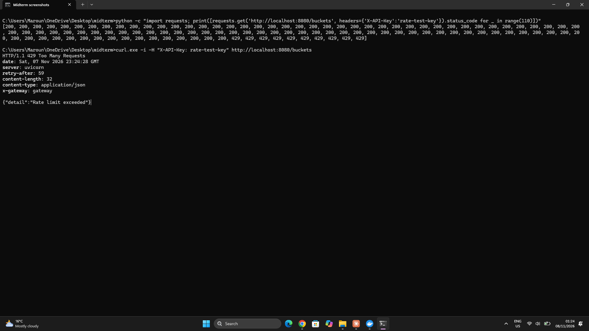

12- Automated tests with pytest
- test_api.py contains 10 tests: authentication, creating and listing buckets, upload and download, byte ranges (including one that crosses a chunk boundary), metadata, list and search, delete, an erasure-coded bucket, cluster status and the rate limit.
- All 10 tests passed against the system running in Docker.
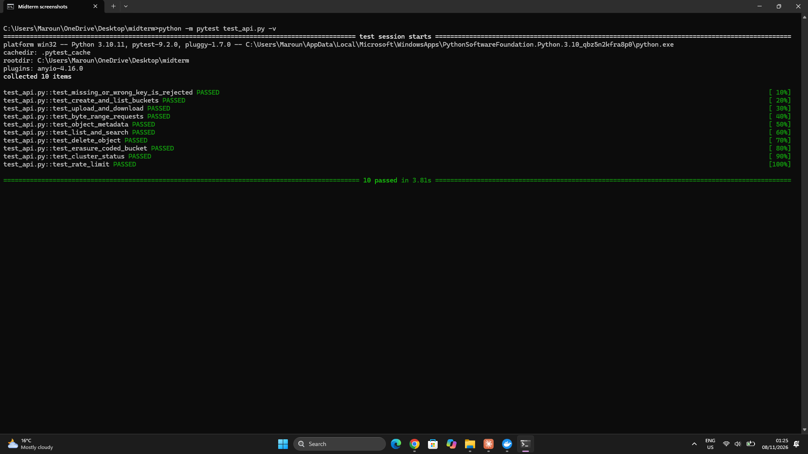

13- Challenges and limitations
- Wrong metadata endpoints: my first gateway called /upload, /download and /search, which the metadata service didn't have. I added the list, search, metadata, range and cluster endpoints to the metadata service and made the gateway use them.
- Uploads rejected with 422: the file was declared as a bytes parameter, which FastAPI reads as a query parameter. The gateway now streams the request body instead.
- Range header ignored: the parameter name made FastAPI look for a header called range-header, and the 206 answer was treated as an error. The gateway now reads the Range header directly and passes 206 on.
- Rate limit never applied: the slowapi limiter was created but not attached to any route. I replaced it with a small limiter inside the API key check.
- Address inside Docker: the gateway used localhost to reach the metadata service, which doesn't work between containers. It now uses http://metadata:8000.
- Limitation: the rate limit is kept in the gateway's memory, so with several gateways (bonus Task 7) each one would count separately.
- Limitation: a full download is assembled in the metadata service's memory, so very large files are better read in parts with byte ranges.
Conclusion
The gateway exposes an S3-like API on top of the storage layer: buckets, uploads, downloads with byte ranges, metadata, search, delete and cluster status, all protected by API keys and a rate limit. The gateway forwards upload bodies as streams, although the metadata service currently buffers the complete body before chunking. All 10 automated tests pass.
Task 6: Build a Simple Web UI
1- Design
- The web interface is a single page, ui/index.html, written with Vue.js 3 (version 3.4). The Vue file, vue.global.prod.js, is stored in the same folder, so the page needs no internet access.
- The page is served by its own nginx container, built from ui/Dockerfile. nginx also forwards every request under /api/ to the FastAPI gateway from Task 5 (ui/nginx.conf), so the browser talks to one address and no CORS setup is needed.
- nginx forwards uploads to the gateway without buffering them and without a configured size limit. The metadata service then reads the complete request body into memory before chunking it, as described in Task 5.
- Every request carries the API key in the X-API-Key header, so the authentication and the rate limit from Task 5 also protect the UI.
- The page has three tabs: Objects, Cluster and Search.
2- Deployment
- I added two services to docker-compose.storage.yml: ui, built from the ui folder on port 8081, and elasticsearch (version 8.13.4, single node, security disabled, a 512 MB heap, its own volume es_data, port 9200).
- The metadata service gets the address of Elasticsearch through the ELASTIC_URL variable.
- I started everything with docker compose -f docker-compose.storage.yml up -d --build, then opened http://localhost:8081 and connected using the configured demonstration API key.
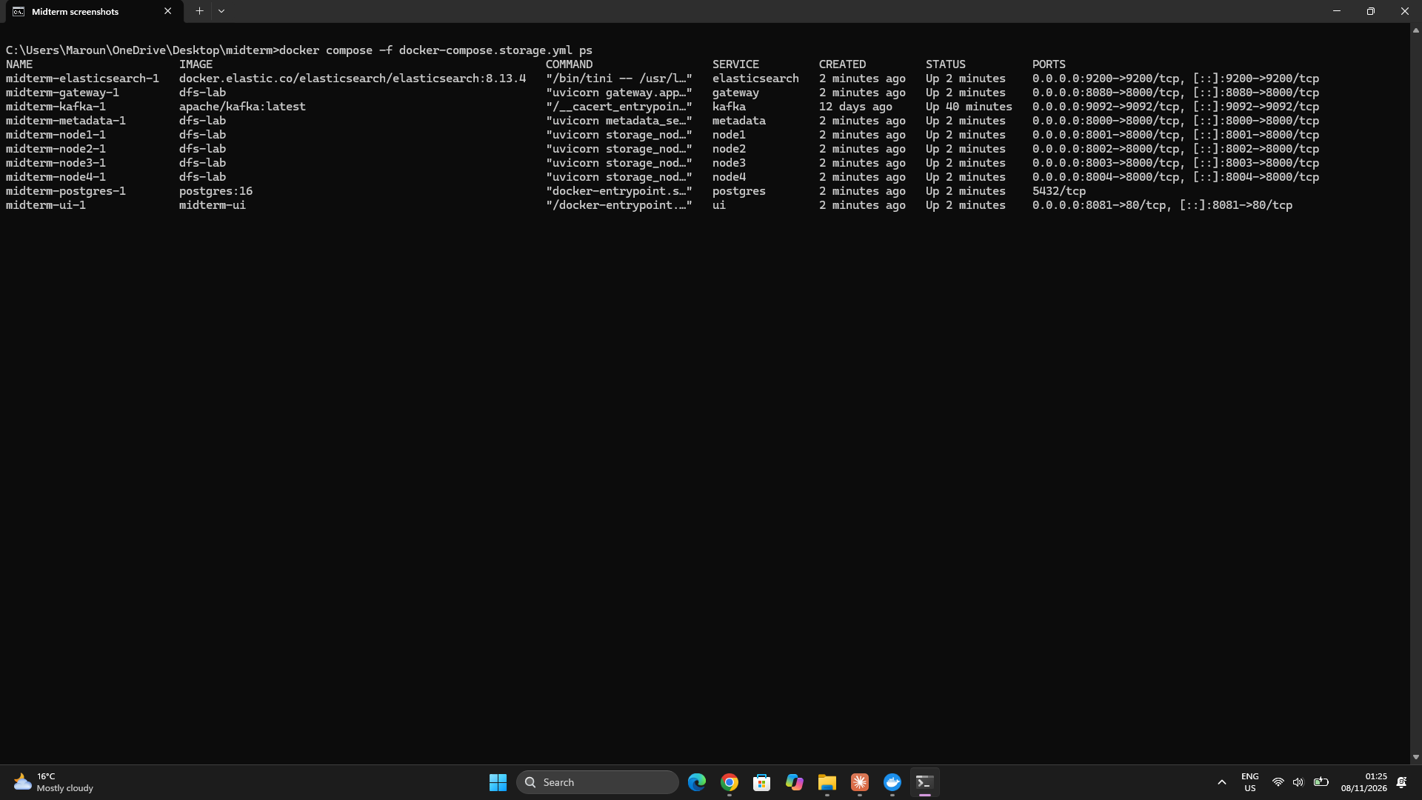

3- Objects: upload, download and browse
- I can choose a bucket, or create a new one in replication or erasure-coding mode.
- To upload, I choose a file, an object key (the file name by default) and optional tags such as type:report, owner:maroun. The file is sent in one streamed PUT request, and a progress bar shows how much has been sent. At the end, a message shows how many chunks were stored, and how many of them were new or deduplicated.
- The table lists the latest version of each object with its size, version, creation date and tags, and it can be filtered by key prefix.
- Each object has a Download button, which saves it under its original name, and a Delete button.
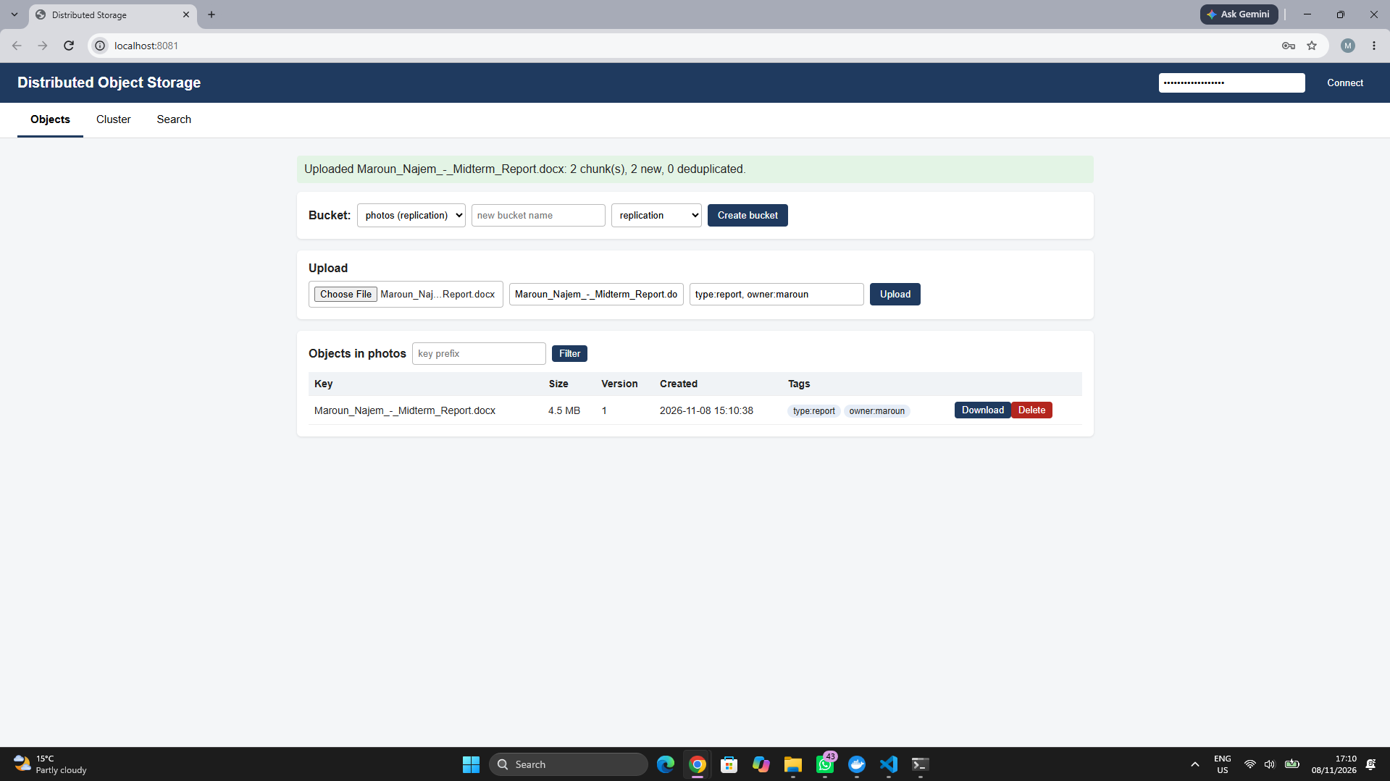

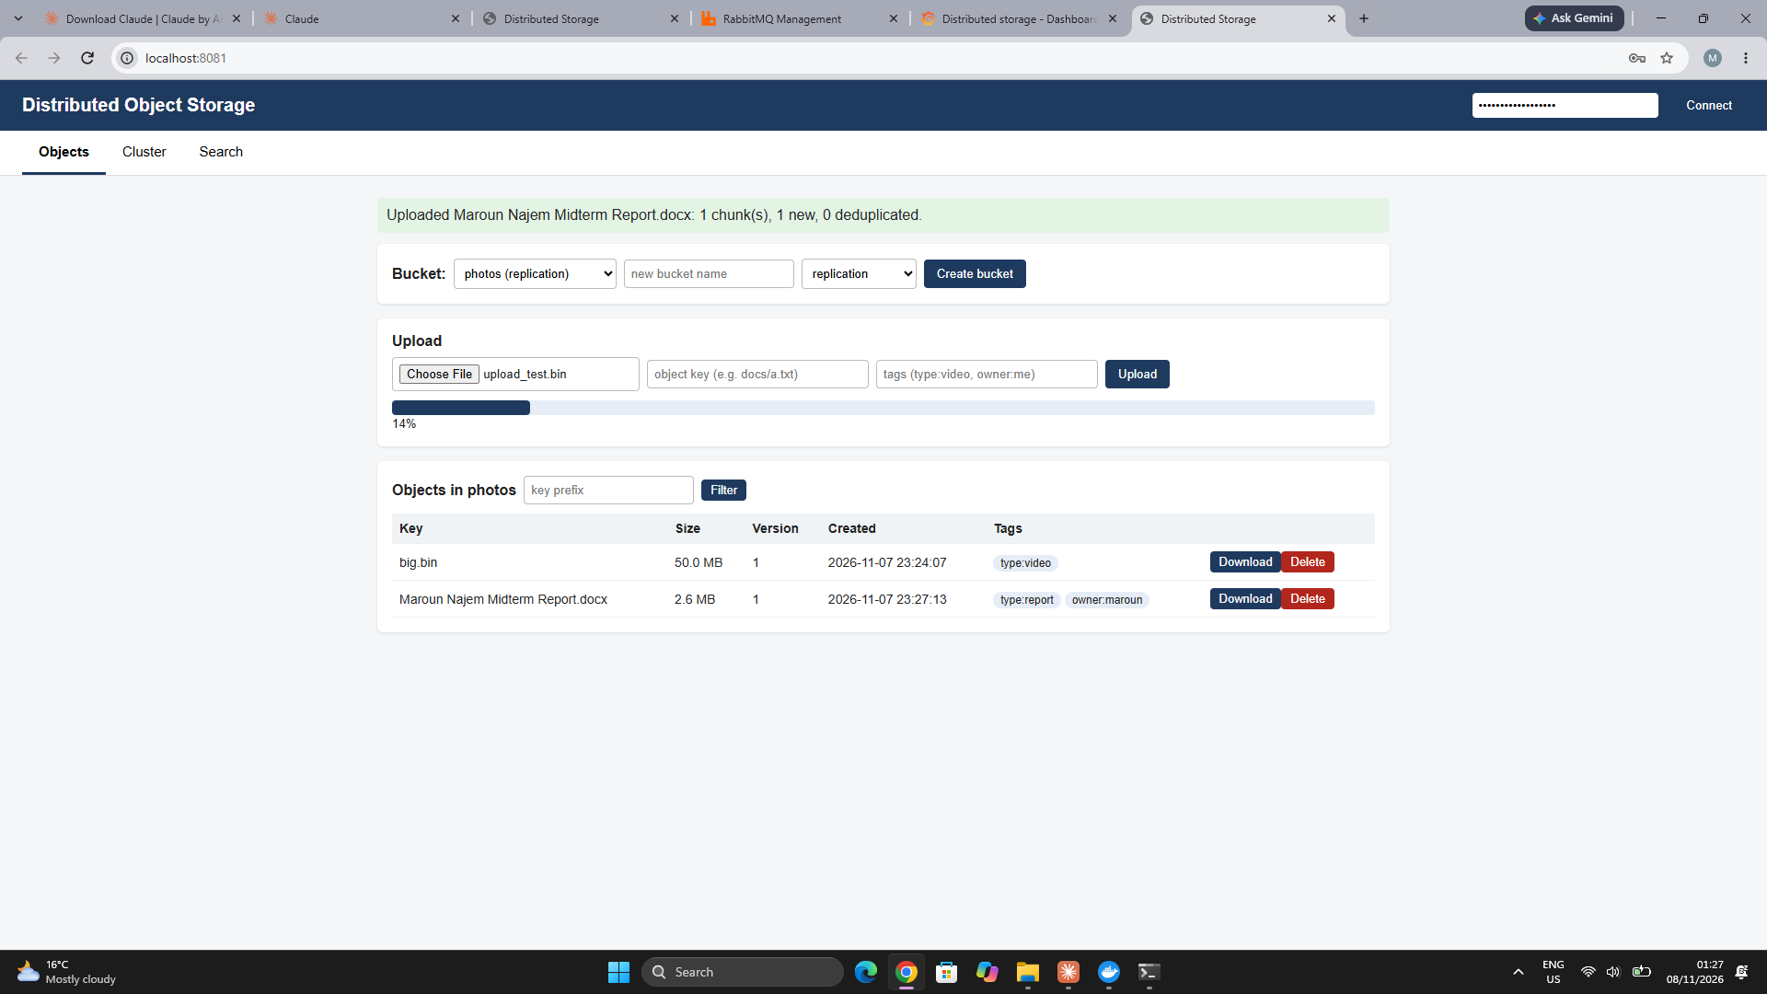

4- Cluster state
- The Cluster tab reads GET /cluster/status from the gateway every 3 seconds.
- Cards at the top show the number of nodes alive, degraded objects, degraded chunks, chunks repaired and chunks fixed by the scrubber.
- The node table shows, for each node, its status (UP or DOWN, based on its heartbeats), its chunk count, a bar for the chunk distribution, the used space and the free space.
- A banner shows the repair progress: "All objects are fully protected" when nothing is degraded, or "Repair in progress" with the number of chunks still on failed nodes. That number goes down while the repair job from Task 4 rebuilds the chunks, and the chunks repaired counter goes up.
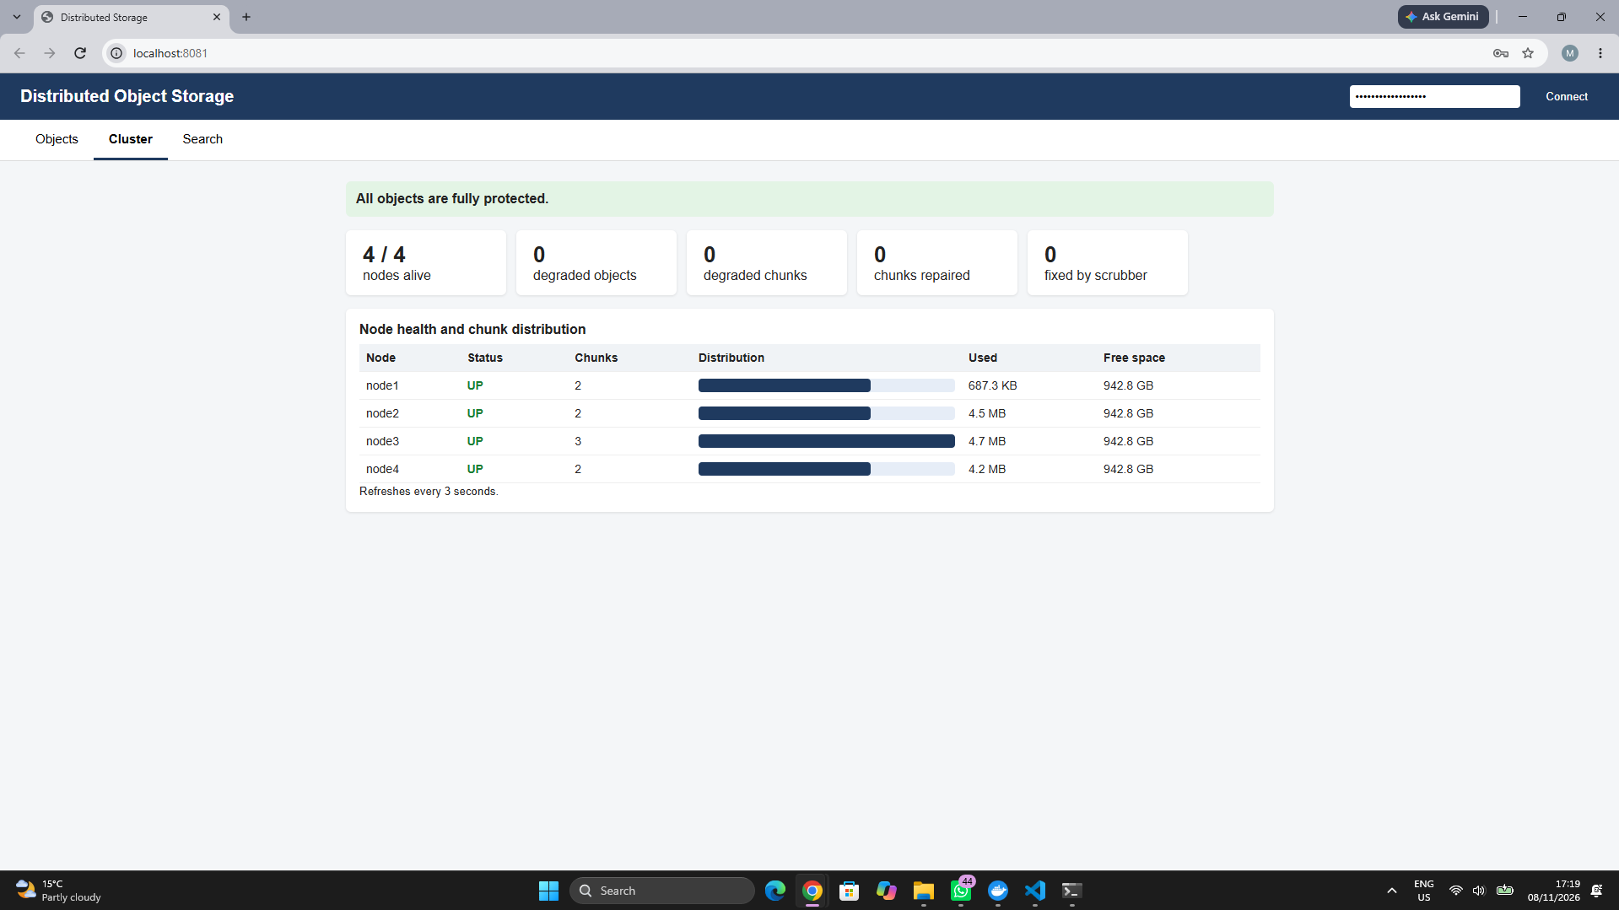

5- Node failure seen in the UI
- I stopped node3 with docker compose -f docker-compose.storage.yml stop node3.
- After about 15 seconds without a heartbeat, node3 showed DOWN and the node count dropped to 3 / 4.
- While the repair job rebuilt its chunks on the other nodes, the banner showed "Repair in progress" and the chunks repaired counter went up.
- I then started node3 again with docker compose -f docker-compose.storage.yml start node3.
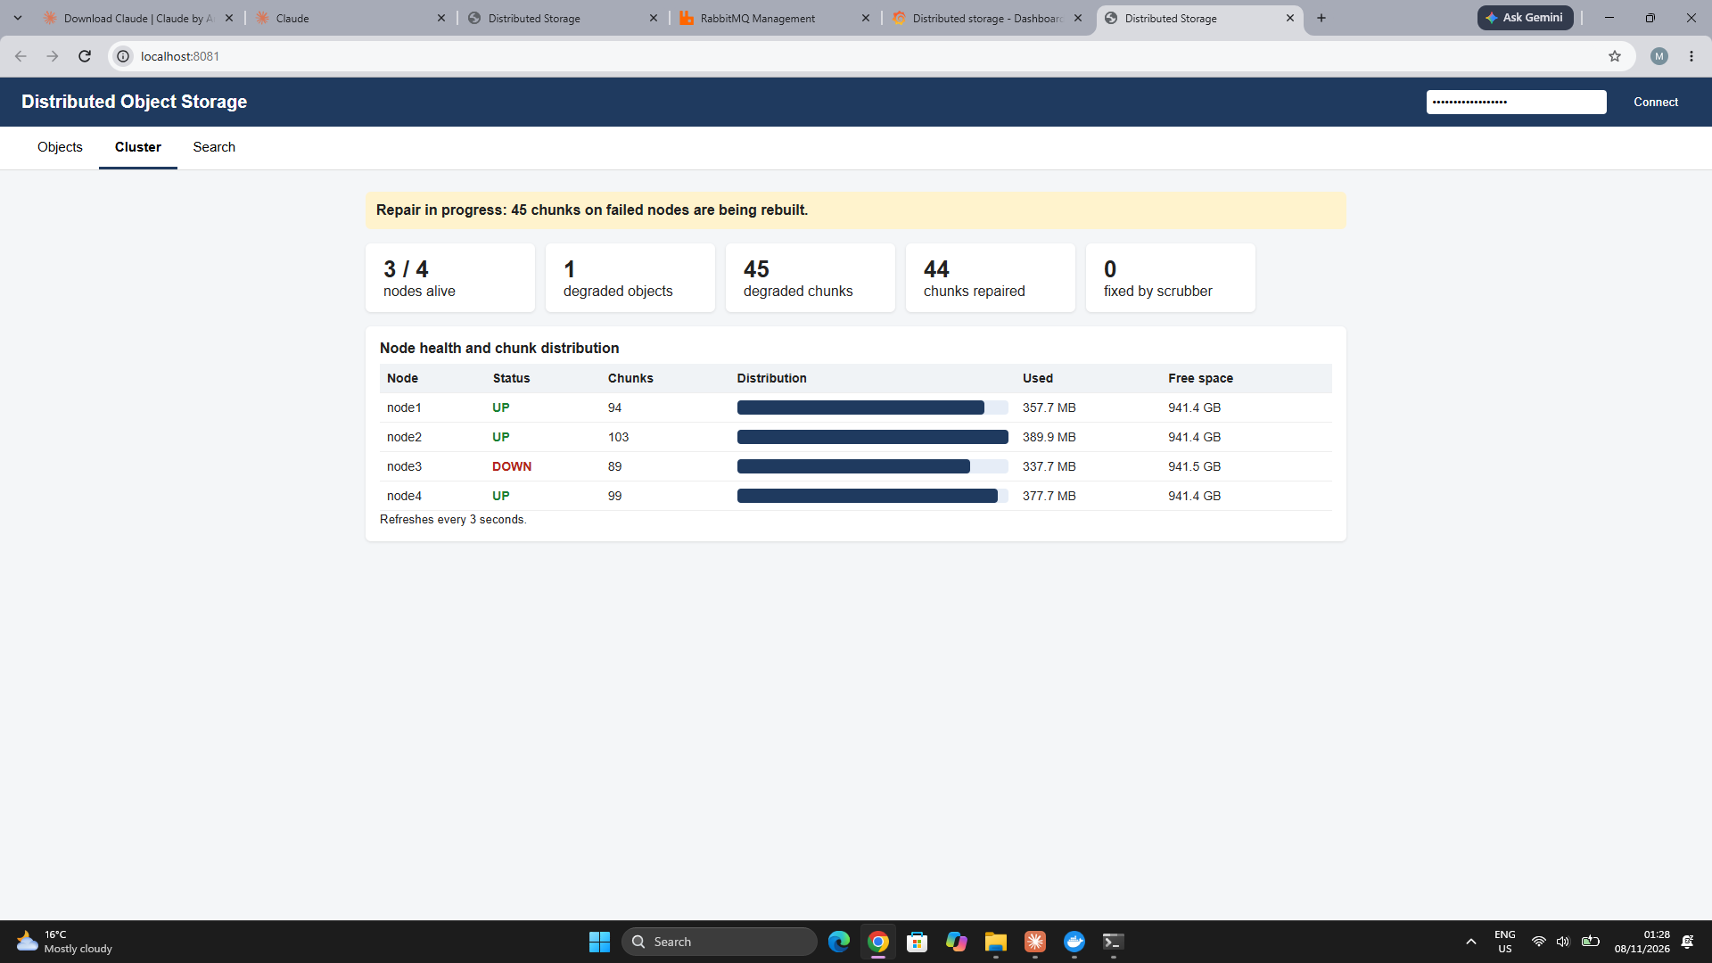

6- Search with Elasticsearch
- When an object is uploaded, the metadata service adds a document to the Elasticsearch index objects, with its bucket, key, version, size, creation date and tags. The document ID is bucket/key, so a new version replaces the old entry, and deleting an object also removes it from the index.
- GET /search?q=... on the gateway runs a search on the key, the bucket name and the tags, without case sensitivity. For example, report finds every key that contains "report", and owner:maroun finds the objects with that tag.
- The Re-index all objects button (POST /search/reindex) indexes every object already stored in PostgreSQL. This is needed for objects uploaded before Elasticsearch was running.
- The index is only a copy of the metadata. If Elasticsearch is down, uploads still work, and only the search returns an error.
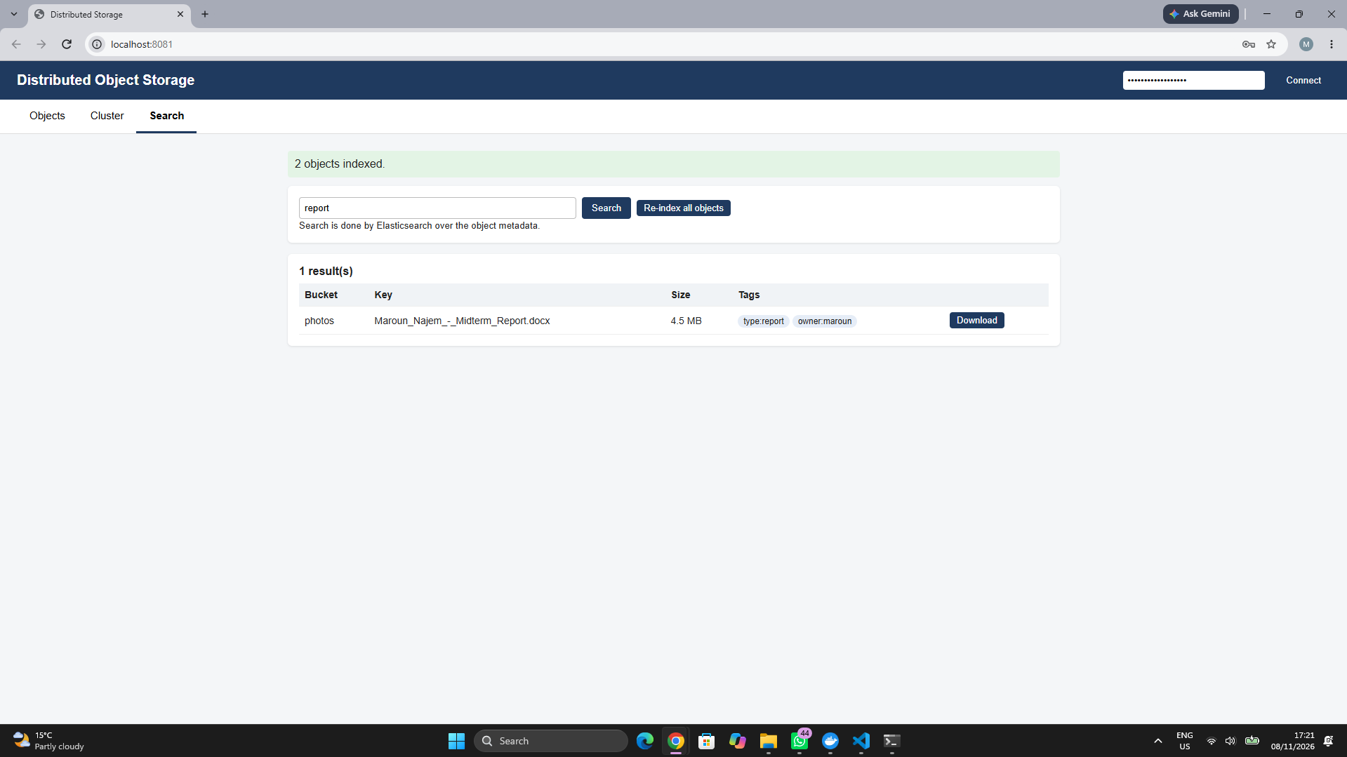

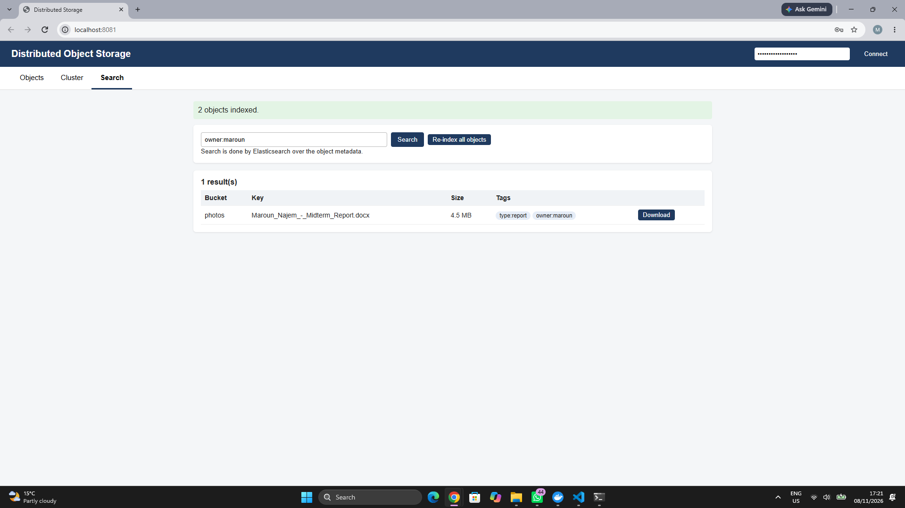

7- Challenges and limitations
- Missing nginx.conf: the first build of the ui container failed with "/nginx.conf": not found, because the file wasn't saved under that exact name. I created ui/nginx.conf again and rebuilt.
- Slow Elasticsearch download: the image is large, so I started the other services first, and Elasticsearch once the download finished.
- Search route not found: POST /search/reindex returned 404 through the gateway but worked on the metadata service directly. My gateway/app.py was still the Task 5 version, so I added the /search and /search/reindex routes and rebuilt the gateway.
- Empty Cluster tab: /nodes returned [] and GET /health on a node returned 404, so the storage node containers were running old code that sent no heartbeats. After checking storage_node/app.py and rebuilding node1 to node4 with --build, all 4 nodes registered again.
- Uneven chunk distribution: node3 still held about 9,000 old chunks from the Task 4 benchmark, so I reset the volumes with docker compose -f docker-compose.storage.yml down -v before taking the screenshots.
- Limitation: a download is fully loaded in the browser before it is saved, so very large files are better fetched with a byte-range request through the API.
- Limitation: Elasticsearch runs as a single node. Its index can be rebuilt from PostgreSQL at any time with the re-index button.
Conclusion
The web interface lets a user upload, download, browse and delete objects. It shows the health of the nodes, the chunk distribution and the repair progress, and it searches object metadata with Elasticsearch. It only talks to the gateway, so it uses the same API key and rate limit as any other client. Uploads are forwarded to the gateway without nginx buffering, but the metadata service currently reads the full request body into memory before chunking.
Task 7 (Bonus): Load Balancing and Fault Tolerance
1- Overview
- Task 7 runs from its own compose file, docker-compose.task7.yml. It contains the whole system plus the new services: an Nginx load balancer, a second gateway, RabbitMQ with two workers, two PostgreSQL standbys, Prometheus and Grafana.
- The storage nodes can also run in Kubernetes as a StatefulSet, defined in k8s/dfs.yaml.
- New files: lb/nginx.conf, metadata_service/jobs.py, metadata_service/worker.py, monitoring/prometheus.yml, monitoring/grafana/, k8s/dfs.yaml and test_task7.py. Changed files: metadata_service/app.py and db.py, gateway/app.py, storage_node/app.py (new GET /chunks) and the Dockerfile (pika added).
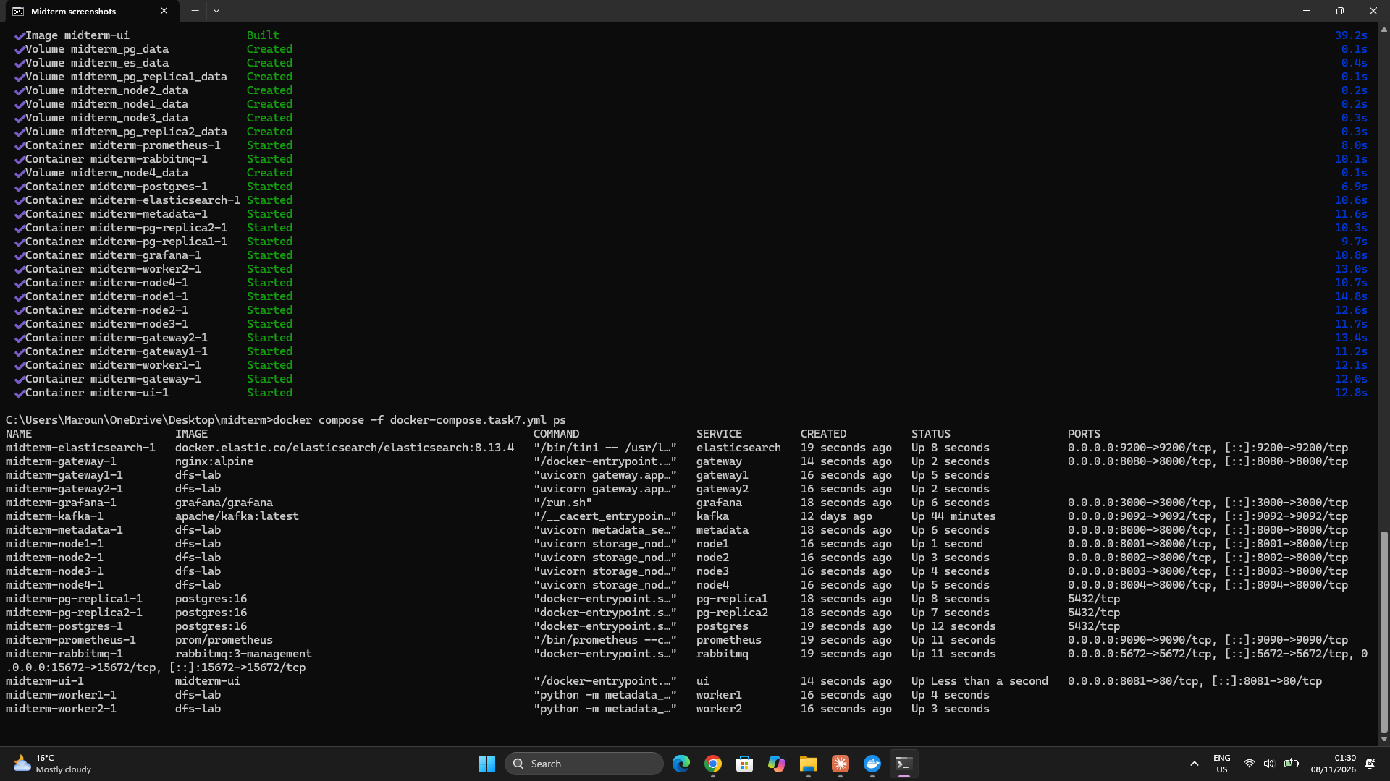

2- Load balancer in front of two gateways
- Nginx (lb/nginx.conf) sends the requests to gateway1 and gateway2 in turn (round robin). It keeps the name gateway and the port 8080, so the UI and the tests of Task 5 work without any change.
- Each gateway adds an X-Gateway header to its answers, which shows which one answered.
- If a gateway stops, Nginx gets a connection error within 2 seconds, sends the request to the other gateway, and skips the failed one for 10 seconds.
- Test: 20 requests were shared equally between the two gateways. With gateway1 stopped, all 20 went to gateway2 without any error.
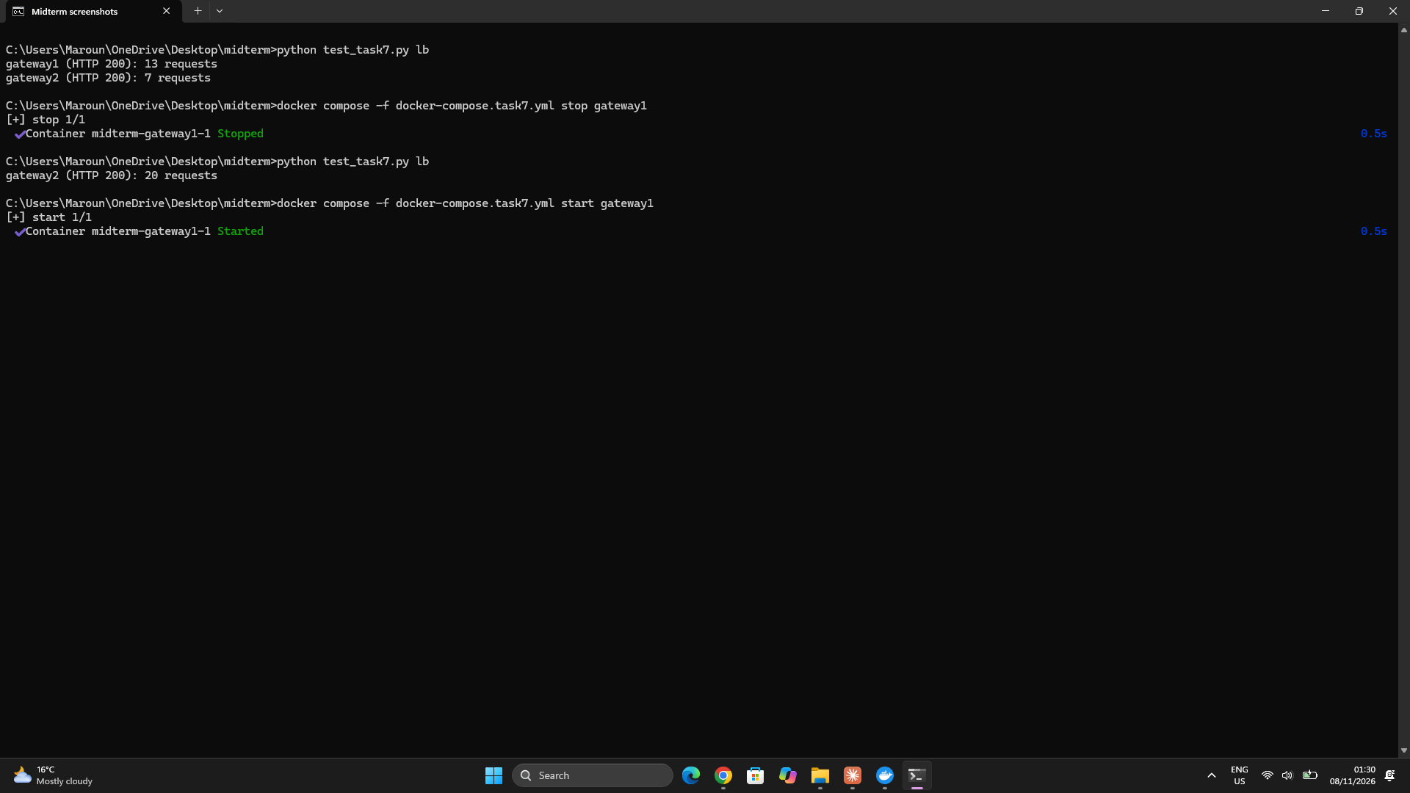

3- Job queue with RabbitMQ and workers
- The metadata service no longer does the background work itself. Every 5 seconds it checks the nodes and puts jobs in a RabbitMQ queue called jobs (metadata_service/jobs.py):
- repair: one job per chunk of a node that just failed;
- rebalance: one job per chunk when a new or emptied node joins;
- gc (garbage collection): one job per node every 2 minutes, which deletes the files that the metadata no longer places on that node;
- scrub: one job per chunk every minute.
- Two workers, worker1 and worker2 (metadata_service/worker.py), take the jobs. RabbitMQ gives each job to only one worker, and with prefetch_count=1 a worker takes a new job only after finishing the last one, so the work is shared between them. Repair jobs have the highest priority, so they pass before scrub jobs.
- The workers send their results to the metadata service, so the counters still appear in the UI. Without RabbitMQ (docker-compose.storage.yml), the metadata service still does the jobs itself, as in Task 4.
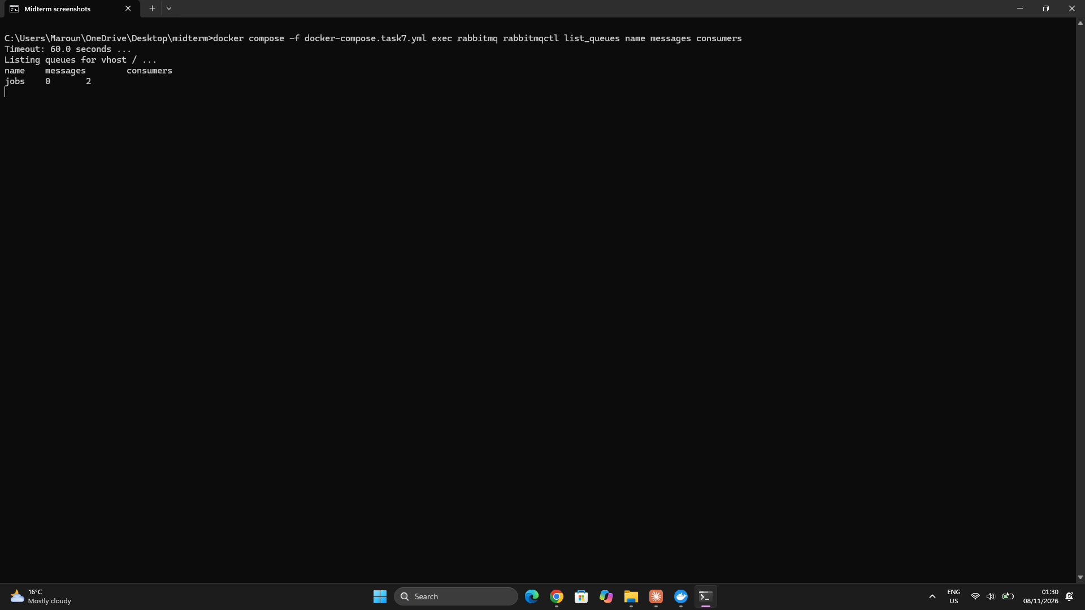

4- Failure, repair and garbage collection through the queue
- I uploaded 10 objects to a replicated bucket and 10 to an erasure-coded bucket, then stopped node3.
- After 15 seconds the metadata service put one repair job in the queue for each chunk that was on node3, and both workers repaired about half of them. All 20 objects stayed identical to the originals.
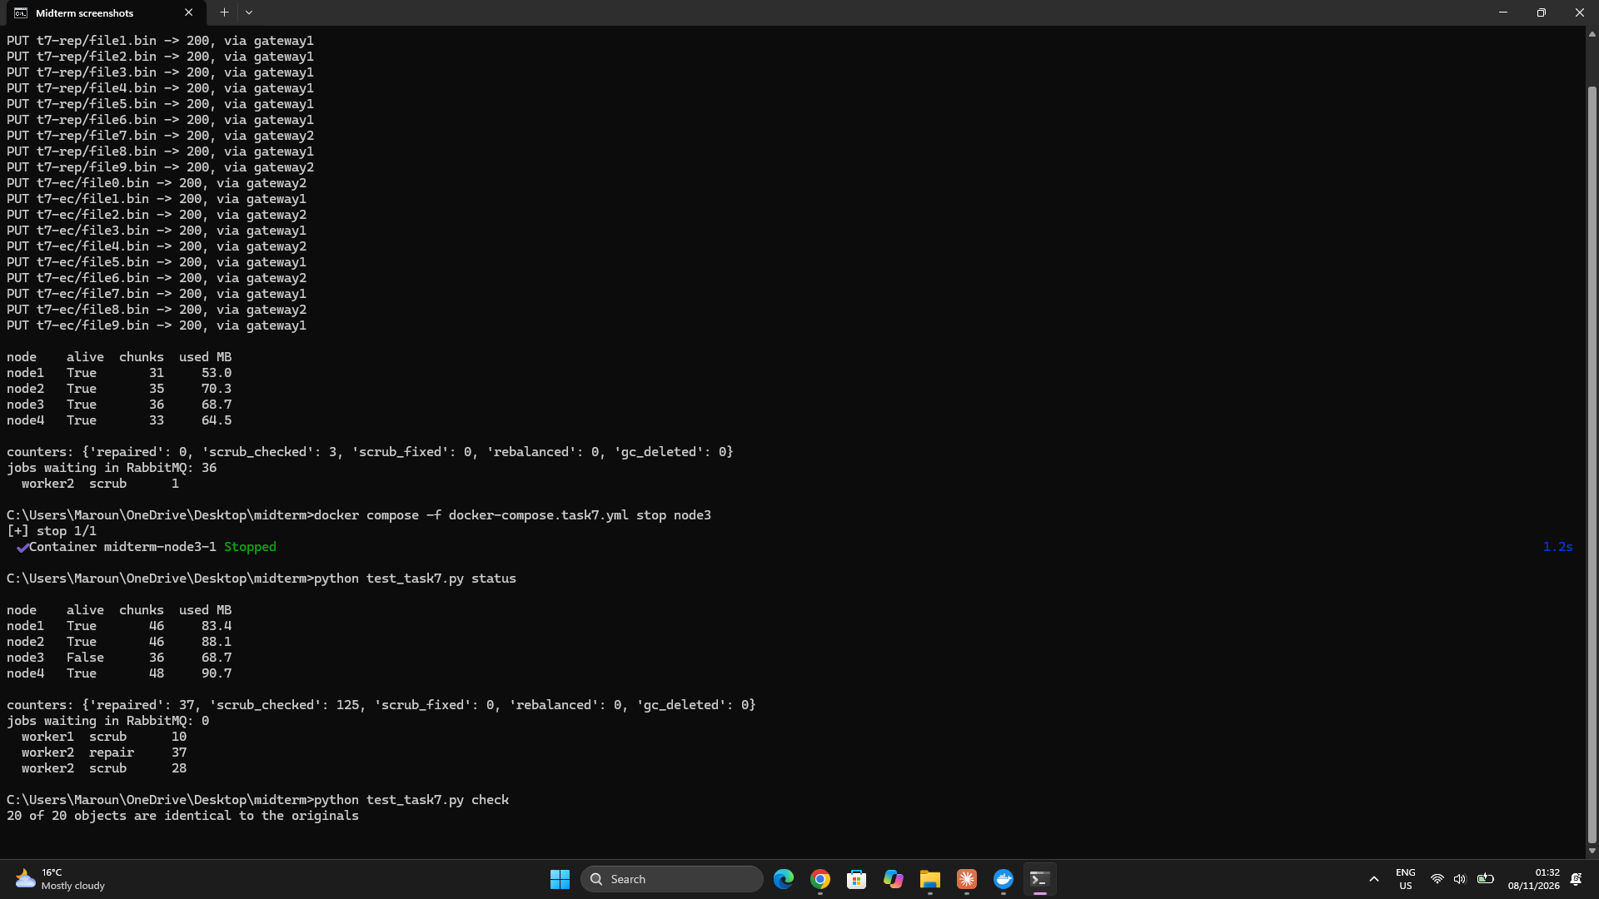

- When node3 came back with its old copies, the metadata no longer placed any chunk on it. Rebalance jobs moved its share back to it, reusing the old copies already on its disk, and a garbage-collection job then deleted the old copies that were no longer needed.
- This solves the Task 4 limitation of the old copies kept by a returning node.
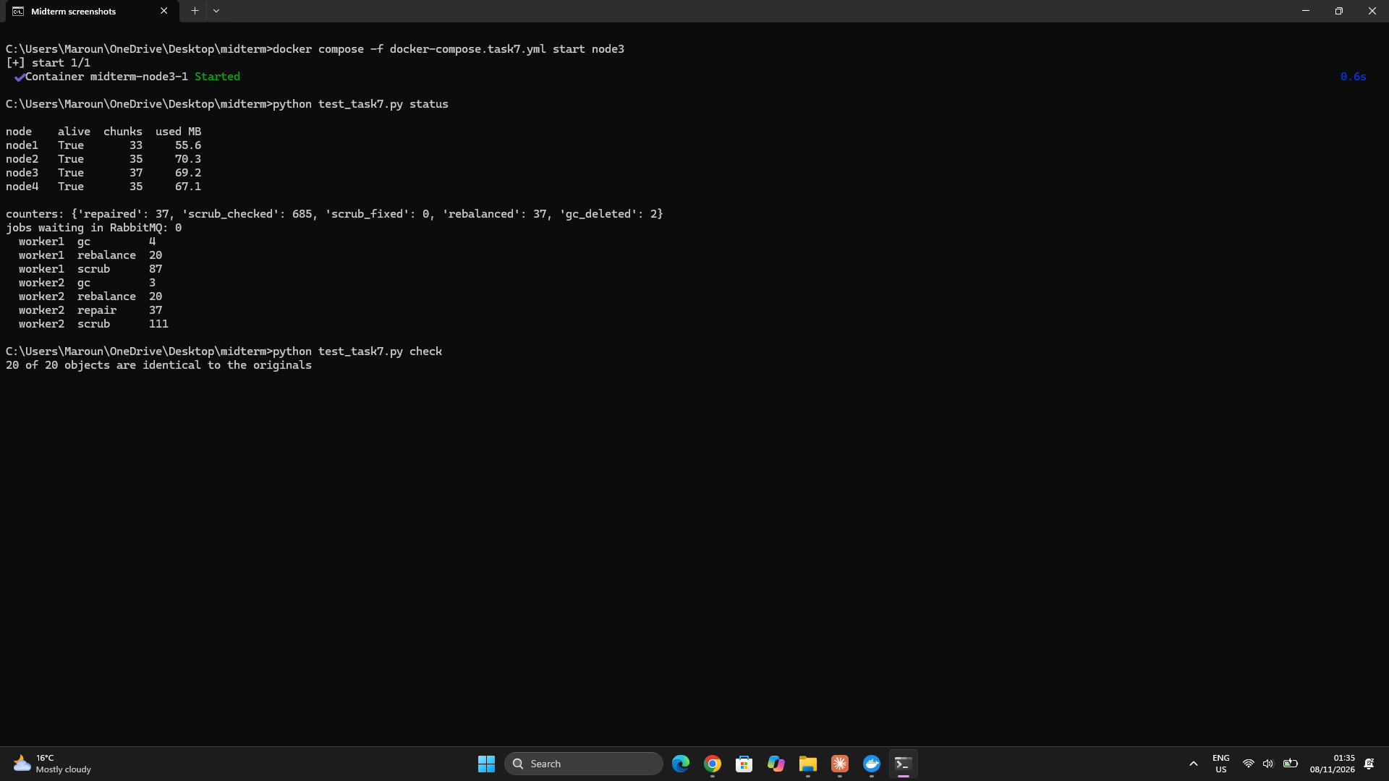

5- Adding a node: rebalancing
- I started a fifth node, node5, which is in the compose file but only starts when asked for.
- The metadata service put one rebalance job per chunk in the queue, and the workers moved to node5 each copy or shard that the hash ring now places on it, deleting it from its old node. Only these pieces move, which is the property of consistent hashing measured in Task 3.
- All objects stayed identical to the originals.
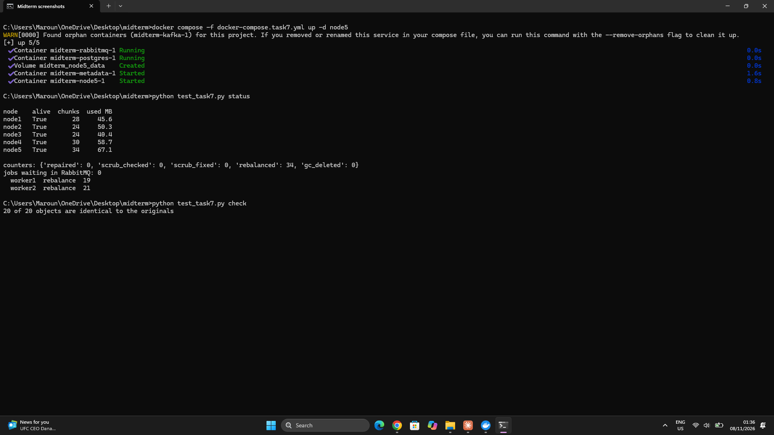

6- Replicated PostgreSQL
- The metadata is stored on 3 PostgreSQL servers: postgres (the primary), pg-replica1 and pg-replica2 (the standbys). Each standby copies the primary once with pg_basebackup, then receives every change by streaming replication.
- The metadata service and the workers connect with a connection string that lists the 3 servers with target_session_attrs=read-write, so they always use the server that accepts writes.
- Failover test: I stopped the primary and promoted pg-replica1 with SELECT pg_promote(). The metadata service switched to it by itself, uploads worked again, and pg-replica2 started following the new primary.
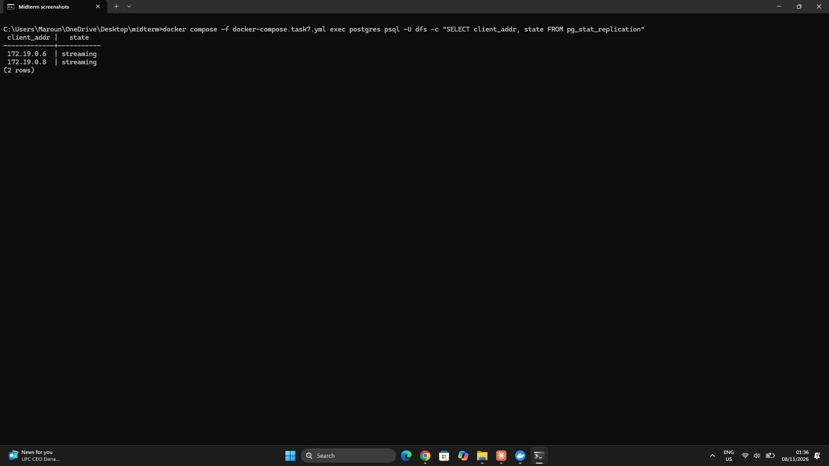

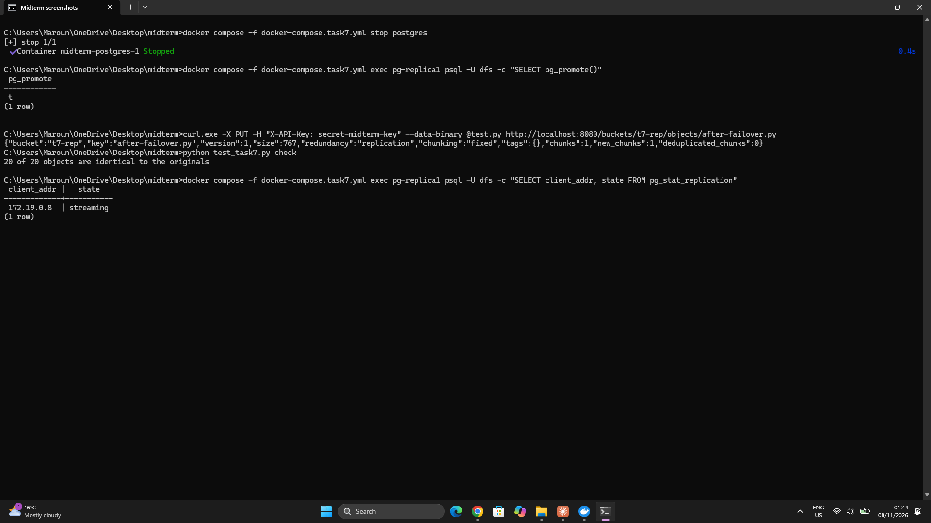

7- Monitoring with Prometheus and Grafana
- The gateways and the metadata service publish their numbers at /metrics, in the Prometheus text format, and Prometheus (monitoring/prometheus.yml) reads them every 5 seconds.
- Gateways: number of requests, total time, errors, and bytes received and sent. Metadata service: for each node, whether it is up, its used and free space and its chunk count; degraded chunks and objects; repaired, rebalanced, garbage-collected and scrub-fixed chunks; jobs waiting and jobs done by each worker.
- Grafana loads the Prometheus data source and the dashboard by itself from monitoring/grafana. The dashboard Distributed storage, at http://localhost:3000, shows the throughput, the latency, the disk usage per node, the degraded objects, the repair rate and the jobs of each worker.
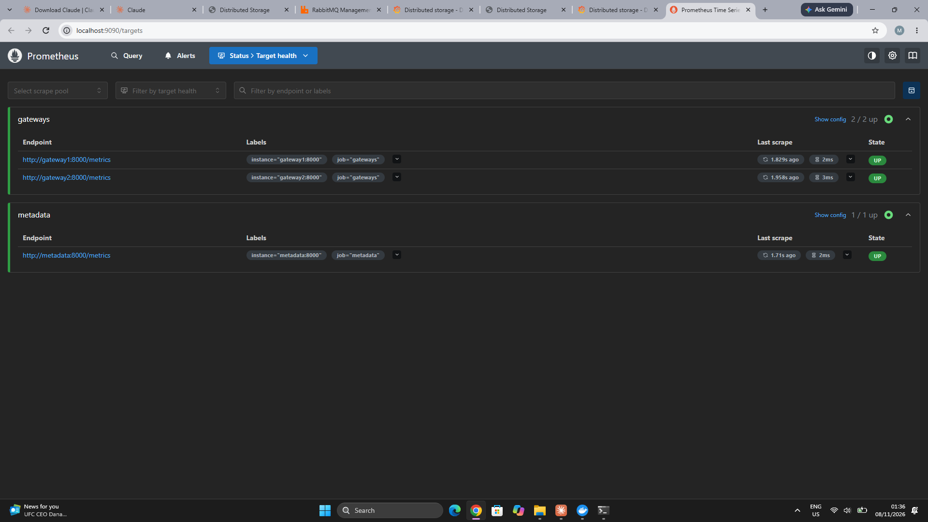

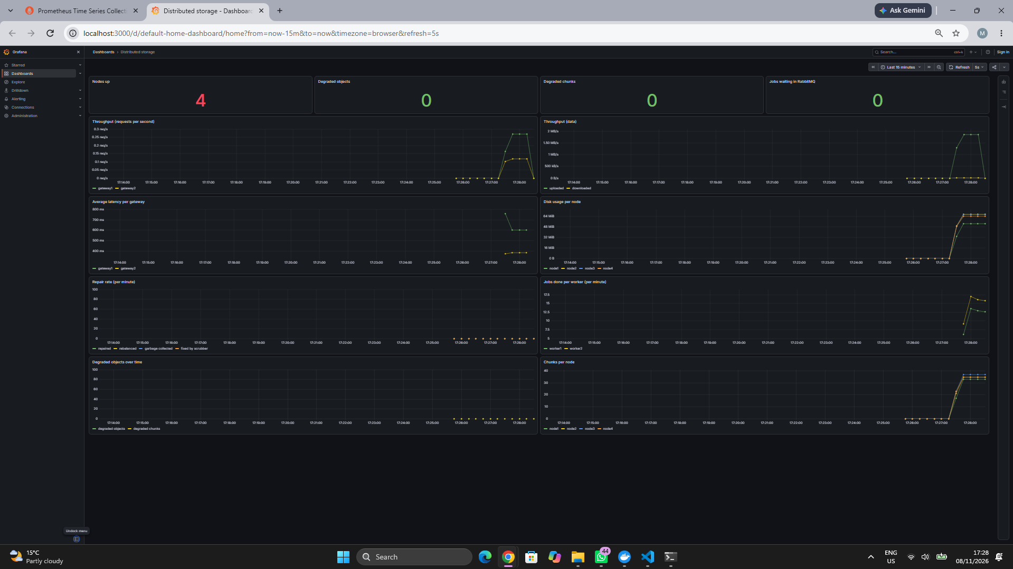
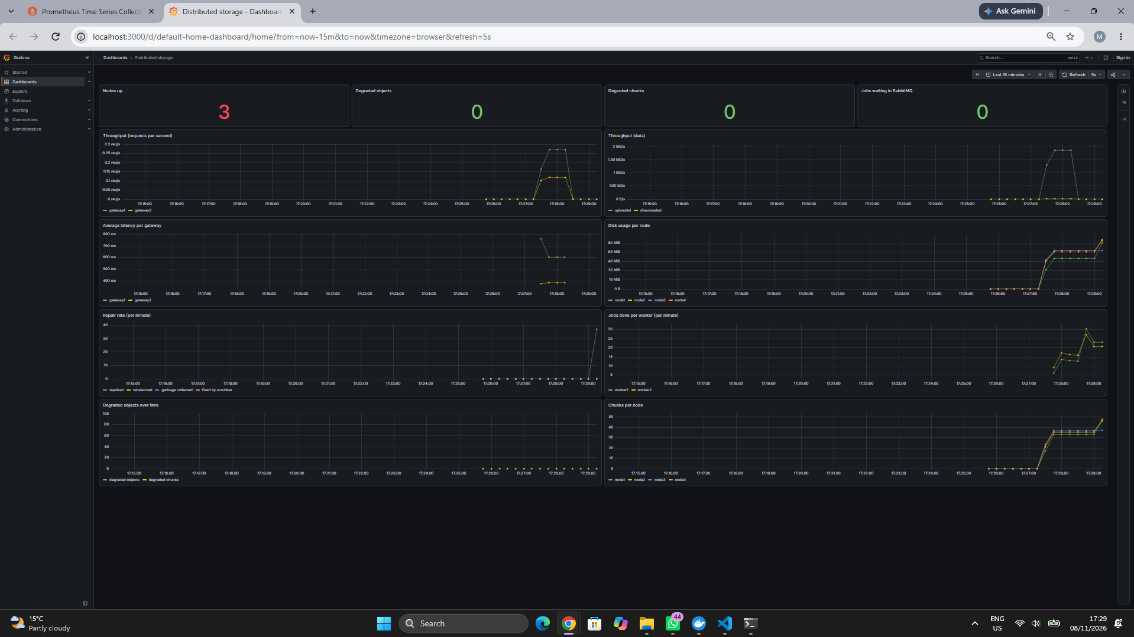

8- Storage nodes as a Kubernetes StatefulSet
- k8s/dfs.yaml creates, in the namespace dfs, PostgreSQL, the metadata service (http://localhost:30800) and the storage nodes as a StatefulSet of 4 pods, node-0 to node-3.
- Each pod keeps a stable name (for example node-0.node) and its own persistent volume (volumeClaimTemplates), which is kept when the pod is recreated.
- A liveness probe calls /health every 10 seconds, and after 3 failures Kubernetes restarts the container. A readiness probe sends traffic to a pod only when /health answers.
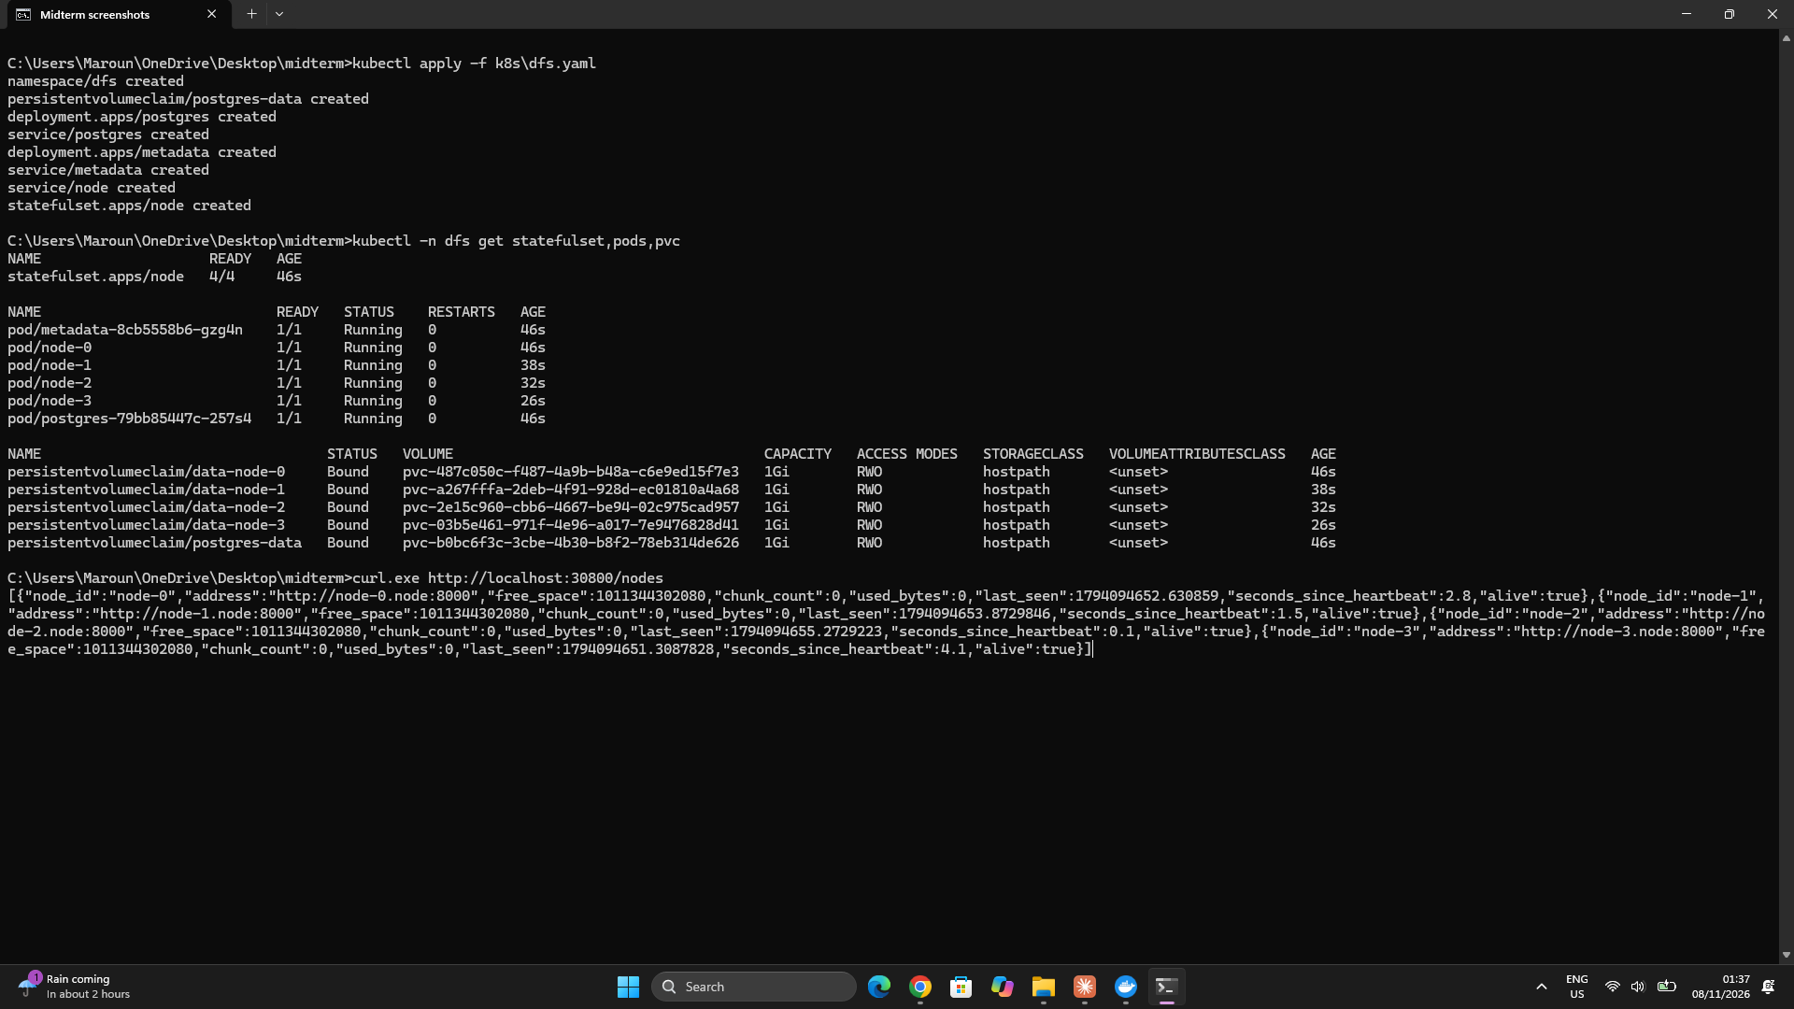

- Pod failure: after kubectl delete pod node-2, the StatefulSet recreated node-2 with the same name and the same volume. It still held the same number of chunks, and the object stored before was still readable.
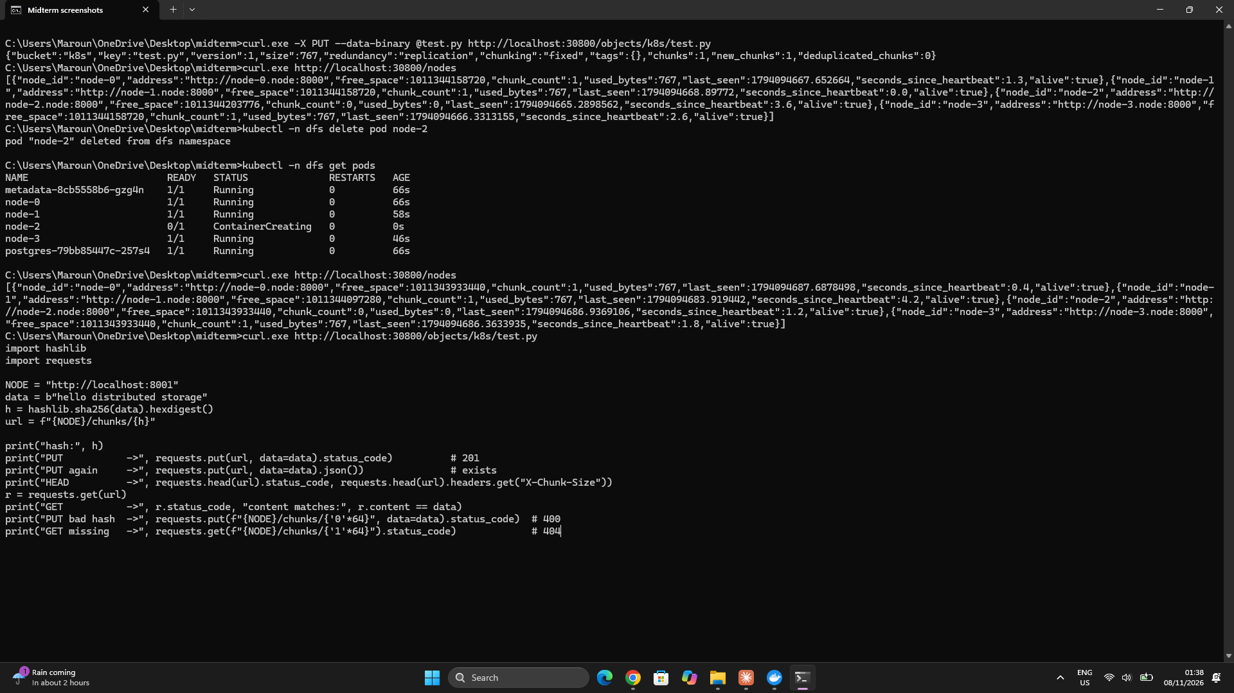

- Liveness: I froze the server inside node-1. /health stopped answering, the liveness probe failed 3 times, and Kubernetes restarted the container by itself (RESTARTS went to 1).
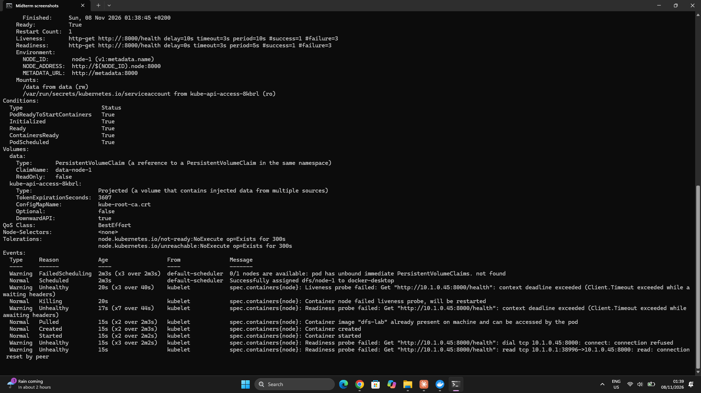

9- Challenges and limitations
- Comma in a list value: in the compose file, the value OTHERS=postgres,pg-replica2 written inside [ ] was split in two at the comma, so it had to be put in quotes.
- Garbage collection too careful: the first version kept old erasure-coding shards, because it only checked that the chunk had some shard on the node. It now checks the exact shard position.
- Uneven repair: all erasure-coded repairs went to node1, the first of the nodes with the fewest shards. Ties are now broken in hash-ring order, so repairs are spread over the nodes.
- Limitation: the database failover is manual (one pg_promote command). A tool such as Patroni would do it automatically. After a failover, the old primary must be rebuilt as a standby, not restarted as a primary.
- Limitation: each gateway keeps its own rate-limit counter, so through the load balancer a key can send about 100 requests per minute to each gateway.
- Limitation: the Kubernetes manifest deploys PostgreSQL, the metadata service and the storage nodes, but not the complete Task 7 stack. The gateways, load balancer, RabbitMQ workers, Prometheus and Grafana are still run through Docker Compose. Deploying the entire system on Kubernetes is left for Task 8.
- Limitation: Grafana opens without a login (anonymous admin), which is fine for a lab but not for production.
Overall Conclusion
The project developed a distributed object-storage system across several stages. It supports content-addressed chunk storage, fixed-size and content-defined chunking, metadata management, consistent-hashing placement, deduplication, replication and erasure coding. A FastAPI gateway provides authenticated object and bucket operations, while the web interface supports browsing, uploads, downloads, cluster status and metadata search. The bonus implementation adds gateway load balancing, queued background jobs, PostgreSQL streaming replication, monitoring with Prometheus and Grafana, and a Kubernetes deployment for the storage nodes and supporting metadata components.
The tests demonstrate that objects remain readable through node failures when sufficient replicas or shards are available, corrupted chunks can be detected and repaired, and new nodes can be incorporated through rebalancing. The benchmark results show the storage and repair-traffic advantages of erasure coding, while also showing its processing cost for small files. The system still has limitations, including manual PostgreSQL failover, per-gateway rate-limit counters, metadata-side buffering of complete uploads, and the fact that the full stack is not yet deployed on Kubernetes. These limitations identify clear areas for future improvement.
Conclusion
The system no longer depends on a single gateway, its metadata is kept on three database servers, and its background work is shared by several workers through RabbitMQ. The storage nodes can run in Kubernetes with automatic restarts, and Prometheus and Grafana show the state of the system live.

